

UNIVERSITY OF COMPUTER STUDIES, HINTHADA INTERNSHIP PROJECT

SU WAI HNIN

B.C.Sc. AUGUST, 2026

LEAVE MANAGEMENT SYSTEM
(USER APPROACH)

By

SU WAI HNIN

A Dissertation Submitted in Partial Fulfillment of the
Requirements for the Degree of
Bachelor of Computer Science (B.C.Sc.)
of the

UNIVERSITY OF COMPUTER STUDIES, HINTHADA AUGUST, 2026

ACKNOWLEDGEMENT
Firstly, we would like to sincerely thank Prof. Dr. Tun Myat Aung, Vice-Rector of the University of Computer Studies (Hinthada), for his valuable consultation and suggestion throughout our academic journey.
I also would like to acknowledge my thanks to Dr. Ei Ei Mon, Professor, Head of Faculty of Computer Science, who gives me guidelines throughout this internship.
I would like to express my deepest gratitude to Academic Supervisor, Associate Professor Dr. Hnin Cherry (Faculty of Computer Science), University of Computer Studies, Hinthada for her invaluable guidance, support, and encouragement throughout this project. Her insights and expertise have been crucial to the development and completion of this work. Without her kind direction and proper guidance, we may be less successful. We wish to acknowledgement our supervisor, for their effective support, valuable suggestions, true-line guidance, supervision from beginning to end.
I am profoundly grateful to I would like to express my sincere gratitude to U Tun Khaing (Founder) and Daw Thae Su Wai (Supervisor) from Enterprise Solution Software & Service Co., Ltd. for providing the necessary information, guidance, and technical resources during my internship period. Their dedicated support, insightful advice, and constant care throughout the project have provided immense motivation and inspiration to complete my work successfully.
Furthermore, I extend my heartfelt thanks to all the faculty members and teachers from the Faculty of Computer Science at the University of Computer Studies, Hinthada for their continuous encouragement, mentorship, and support throughout my academic journey.
Finally, I would like to acknowledge the unwavering support of my family and friends, who have been a constant source of encouragement throughout this journey. Thank you all for their contributions and support.

ABSTRACT
The Leave Management System is a web-based application developed to streamline and improve staff leave management at the University of Computer Studies, Hinthada (UCSH). Traditionally, leave requests, approvals, and record keeping in educational institutions are often managed manually through paper-based forms and physical documents, leading to delays, data inconsistencies, and difficulties in tracking leave records. To overcome these challenges, the proposed system provides a centralized platform for managing staff information, departments, leave types, and user accounts. The system defines four distinct user roles: Staff, Department Head, Administrator, and System Admin. Staff members can submit leave applications by specifying a substitute staff member for duty handover, monitor request statuses, and manage their profile details. Department Heads review applications from their respective departments, provide recommendations, and access department-level leave reports. Recommended applications are forwarded to the Administrator for final approval, while non-recommended applications are returned directly to applicants with automated notifications. The System Admin oversees system-level operations and manages administrator accounts. Additionally, the system features leave balance tracking, filtered report generation, and dashboard analytics to support effective administrative decision-making. Developed using the Laravel Framework, PHP, MySQL, HTML, CSS, Bootstrap, and JavaScript, the system offers a secure, scalable, and user-friendly environment. By automating leave workflows and maintaining a centralized database, the system reduces paperwork, minimizes human errors, improves data accuracy, enhances operational efficiency, and contributes to the digital transformation of administrative processes at UCSH.

TABLE OF CONTENTS
Pages

ACKNOWLEDGEMENT i

ABSTRACT ii

TABLE OF CONTENTS iii

LIST OF FIGURES vi

LIST OF TABLES vii

CHAPTER 1 1

INTRODUCTION 1
1.1 Experiences from Internship 2
1.2 Motivation of the System 2
1.3 Objectives of the System 3
1.4 Summary of the Project 4

CHAPTER 2 5

BACKGROUND THEORY 5
2.1 Programming Technology 5
2.1.1 HTML (Hyper Text Markup Language) 5
2.1.2 CSS (Cascading Style Sheets) 7
2.1.3 JS (JavaScript) 8
2.1.4 Laravel Framework 9
2.1.5 Tailwind CSS 10
2.2 Database Management System Technology 11
2.2.1 DBMS (Database Management System) 12
2.2.2 Database Languages in DBMS 13
2.2.3 MySQL 14
2.2.4 Keys in SQL 15
2.2.5 Normalization 16
2.2.6 Laravel Eloquent ORM 17
2.3 Deployment Technology 19
2.3.1 Ubuntu Server 19
2.3.2 Dokploy 19

CHAPTER 3 21

SYSTEM DESIGN 21
3.1 System Flow Diagram 22
3.1.1 System Flow Diagram for Staff 23
3.1.2 System Flow Diagram for Department Head 24
3.2 Use Case Diagram 25
3.2.1 Use Case Diagram for Staff 26
3.2.2 Use Case Diagram for Department Head 27
3.3 Entity Relationship Diagram (ERD) 29
3.4 Data Dictionary 31

CHAPTER 4 37

SYSTEM IMPLEMENTATION 37
4.1 System Requirements 37
4.2 User Interface Design 38
4.2.1 Design for Home Page 39
4.2.2 Design for Login Form 39
4.2.3 Design for Staff Dashboard 40
4.2.4 Design for Leave Requests Information 41
4.2.5 Design for Leave Request Form 41
4.2.6 Design for Profile Page 42
4.2.7 Design for Department Head Dashboard Page 43
4.2.8 Design for Department Head Leave Requests Information 43
4.2.9 Design for Department Head Leave Request 44
4.2.10 Design for Pending Leave Approvals Page 45
4.2.11 Design for Leave Approval History 45
4.2.12 Design for Staff Information 46
4.2.13 Design for Department Head Profile 47
4.2.14 Design for Department Leave Report Interface 47
4.3 Database Management System Implementation 48
4.4 Hosting the Website 51
4.4.1 Server Preparation and Software Installation 51
4.4.2 Database Configuration 52
4.4.3 Laravel Application Deployment 52
4.4.4 Laravel Environment Configuration 53
4.4.5 Directory and File Permissions 54
4.4.6 NGINX Web Server Configuration 55
4.4.7 PHP File Upload Configuration 56
4.4.8 Laravel Optimization and Service Configuration 57
4.4.9 Website Verification 57

CHAPTER 5 59

CONCLUSION 59
5.1 Advantages of the System 60
5.2 Limitations and Future Work 60

REFERENCES 62

LIST OF FIGURES
Pages
Figure 3. 1 System Flow Diagram for Staff 23
Figure 3. 2 System Flow Diagram for Department Head 24
Figure 3. 3 Use Case Diagram for Staff 27
Figure 3. 4 Use Case Diagram for Department Head 28
Figure 3. 5 ER Diagram 30
Figure 4. 1 Home Page Interface 39
Figure 4. 2 Login Form 40
Figure 4. 3 Staff Dashboard Interface 40
Figure 4. 4 Leave Request Interface 41
Figure 4. 5 Leave Request Form 42
Figure 4. 6 Profile Page Layout 42
Figure 4. 7 Department Head Dashboard Page 43
Figure 4. 8 Department Head Leave Requests Information Interface 44
Figure 4. 9 Department Head Leave Request Form 44
Figure 4. 10 Pending Leave Approvals Page Design 45
Figure 4. 11 Approval History Interface 46
Figure 4. 12 Staff Information Page 46
Figure 4. 13 Department Head Profile Interface 47
Figure 4. 14 Department Leave Report Interface 48
Figure 4. 15 Cloning the Leave Management System Repository 53
Figure 4. 16 Successful Deployment of the Leave Management System 58

LIST OF TABLES
Pages
Table 3. 1 Users Table 32
Table 3. 2 Department Table 33
Table 3. 3 Leave Types Table 34
Table 3. 4 Leave Request Table 35
Table 3. 5 Leave Balance Table 36

CHAPTER 1

INTRODUCTION
Leave management is an essential administrative process in every organization, including educational institutions. An effective leave management system helps organizations maintain accurate leave records, monitor staff leave balances, and ensure that leave requests are processed efficiently. Proper leave management not only supports smooth organizational operations but also promotes transparency, fairness, and accountability in managing staff leave. However, traditional manual leave management methods are often time-consuming, prone to human errors, and difficult to maintain, especially in institutions with a large number of staff and departments.
The Leave Management System is a web-based platform designed to support and automate the administration of leave management at the University of Computer Studies, Hinthada (UCSH). The system categorizes user access into four distinct roles: Staff, Department Head, Administrator, and System Admin. The System Admin oversees system-level privileges and manages administrator accounts. Staff members can submit leave applications by selecting a designated substitute staff member for duty handover, track request statuses, and view their personal leave history and manage their profile details. Department Heads review leave applications submitted by staff within their respective departments to provide recommendations; recommended requests are forwarded to the Administrator for final approval, whereas non-recommended applications are returned directly with automated notifications sent to the applicants without escalating to the Administrator. Department Heads can also access and generate department-level leave reports. The Administrator performs final approvals, manages overall staff information, departments, leave types, and leave balances.
This system is developed using the Laravel Framework, PHP, MySQL, HTML, CSS, Bootstrap, and JavaScript. It follows the Model–View–Controller (MVC) architecture, providing a secure, scalable, and maintainable development environment. By digitizing leave workflows, providing comprehensive reporting features, and maintaining a centralized database, the system reduces paperwork, simplifies administrative tasks, improves data accuracy, enhances operational efficiency, and supports the university's digital transformation in administrative management.

1.1 Experiences from Internship
We are final-year Computer Science students at the University of Computer Studies, Hinthada. UCSH provides a five-year program in two main majors: Computer Science and Computer Technology. During the first four and a half years, students engage in theoretical and practical learning along with mini-projects. In the final half-year, students are required to participate in an internship program either at an IT company, a government department, or by working on a designated project at school.
We worked on this intern project in collaboration with a randomly assigned partner, as per the instructor's arrangement. We decided to carry out a university-related project, guided by our supervisor. At first, we were nervous, but gradually we overcame our hesitation and gained confidence. Over three months, we gained valuable hands-on experience by researching, designing, and developing the system, which will be beneficial for our future professional careers.

1.2 Motivation of the System
At the University of Computer Studies, Hinthada (UCSH), staff leave requests and leave records are often managed manually using paper-based forms or spreadsheets. These traditional methods are time-consuming, difficult to organize, and susceptible to human errors. For example, tracking staff leave balances, processing leave requests, and maintaining leave records can become challenging, especially when dealing with multiple departments and a large number of staff members.
The motivation behind developing this system is to provide an accurate, reliable, and efficient leave management system that automates the core functionalities of staff leave administration. With this system, System Admins manage system privileges and administrator accounts, while Administrators manage staff information, departments, leave types, and overall leave balances. Staff members can submit leave applications online by designating a substitute staff member for duty handover, track their request status, and manage their profile details. Department Heads review applications from their respective department staff to provide recommendations and access department-level leave reports; recommended requests are forwarded to the Administrator for final approval, whereas non-recommended applications are returned directly with notifications sent to the staff members without escalating to the Administrator.
By developing this system, the aim is to support UCSH's transition toward digital administration by providing a secure, user-friendly, and centralized platform for managing staff leave records. The system improves data accuracy, minimizes paperwork, enables filtered report generation, reduces the risk of data loss, and enhances the overall efficiency of administrative operations.

1.3 Objectives of the System
The general objective of this system is to develop a web-based Leave Management System that makes the staff leave application, review, approval, and record management processes easier, faster, and more efficient at the University of Computer Studies, Hinthada (UCSH).
The specific objectives of the proposed system are:
- To allow staff members to submit leave applications online by designating a substitute staff member for duty handover and easily check the status of their applications.
- To enable Department Heads to review leave applications submitted by staff from their respective departments and provide recommendations.
- To forward recommended leave applications to the Administrator for final approval and return non-recommended applications directly to the respective staff members with automated notifications.
- To notify staff members about the status and results of their leave applications.
- To reduce errors and delays caused by manual leave application and record-keeping processes.
- To maintain staff information and leave records in a centralized and well-organized database.
- To provide role-based security across four user roles (Staff, Department Head, Administrator, and System Admin), including System Admin privileges for creating and managing administrator accounts.
- To manage staff leave balances and provide accurate information about available and used leave.
- To generate leave reports and summaries to assist administrators and management in monitoring staff leave and making informed decisions.
- To provide dashboard analytics for easier monitoring and understanding of
leave-related information.
- To reduce paperwork and improve the overall efficiency, accuracy, and transparency of the university's leave administration process.
Overall, the proposed system aims to replace the existing manual leave management process with a centralized and automated web-based solution. It is designed to improve communication between staff members, Department Heads, Administrators and System Admins while ensuring that leave applications are processed accurately and efficiently. The system also provides a scalable and maintainable foundation that can be enhanced with additional features in the future as the administrative requirements of UCSH evolve.

1.4 Summary of the Project
The Leave Management System is a web-based application primarily built for UCSH to manage staff leave processes and administrative records. The entire system is controlled by an administrator who performs all core operations including staff registration, department setup, leave type assignment, and leave balance configuration, while enabling a multi-role workflow for staff applications and department head recommendations.
This project book is divided into five chapters:
- Chapter 1 introduces the project, explains the internship experience, outlines the motivation behind the system, states the objectives, and summarizes the structure of the book.
- Chapter 2 discusses the background theory and technologies used in the project, including HTML, CSS, JavaScript, Bootstrap, Tailwind CSS, the Laravel Framework, DBMS, and MySQL.
- Chapter 3 presents the system design, including structural diagrams such as the system flow, use case diagrams , ER diagram, and database schema.
- Chapter 4 covers the implementation details with user interface designs, screenshots, and descriptions of how the system works in real-time.
- Chapter 5 summarizes the system’s benefits, identifies limitations, outlines future improvements, and concludes the project.

CHAPTER 2

BACKGROUND THEORY
This project focuses on the development of the Leave Management System for the University of Computer Studies, Hinthada (UCSH). It is a web-based platform designed to help the school administration manage staff leave processes and attendance records more efficiently, replacing traditional manual procedures that are often time-consuming and error-prone. The purpose of this chapter is to provide the theoretical background and essential technologies used throughout the development of the system. It introduces the core web technologies, frameworks, and database tools that support the structure, functionality, and performance of the application.

2.1 Programming Technology
The Leave Management System for the University of Computer Studies, Hinthada (UCSH) is developed using a robust and reliable web development stack. This includes standard front-end technologies like HTML, CSS, and JavaScript, along with the Laravel Framework, Bootstrap, and Tailwind CSS for responsive interface design. These technologies enable the system to deliver a highly responsive, interactive, and user-friendly interface for managing staff leave requests and administrative records efficiently.

2.1.1 HTML (Hyper Text Markup Language)
HTML (Hyper Text Markup Language) is the most basic building block of the Web. It defines the meaning and structure of web content. Other technologies besides HTML are generally used to describe a web page's appearance/presentation (CSS) or functionality/behavior (JavaScript). "Hypertext" refers to links that connect web pages to one another, either within a single website or between websites. Links are a fundamental aspect of the Web. By uploading content to the Internet and linking it to pages created by other people, you become an active participant in the World Wide Web. HTML uses "markup" to annotate text, images, and other content for display in a Web browser. HTML documents are made up of elements, which are defined by tags. Tags are written with angle brackets: <tagname> content </tagname> such as <head>, <title>, <body>, <p>, <img>, <ul>, <ol>, <li> and many others. An HTML element is set off from other text in a document by "tags", which consist of the element name surrounded by "<" and ">". The name of an element inside a tag is case-insensitive. That is, it can be written in uppercase, lowercase, or a mixture. For example, the <title> tag can be written as <Title>, <TITLE>, or in any other way. However, the convention and recommended practice is to write tags in lowercase.
The following example demonstrates the basic structure of an HTML document, including headings, unordered and ordered lists, and a paragraph:

<!DOCTYPE html>
<html>
<head>
<title>Leave Management System</title>
</head>
<body>
<h1>Departments</h1>
<ul>
<li>Faculty of Information Science</li>
<li>Faculty of Computer Science</li>
<li>Finance</li>
</ul>
<h6>Leave Types</h6>
<ol>
<li>Annual Leave</li>
<li>Medical Leave</li>
<li>Casual Leave</li>
<li>Maternity Leave</li>
<li>Study Leave</li>
<li>Emergency Leave</li>
</ol>
<p>This system allows staff members to submit and monitor their leave applications online. </p>
</body>
</html>
The following points explain the main HTML elements and tags used in the example:
- The <!DOCTYPE html> declaration represents the document type, and helps browsers to display web pages correctly. It must only appear once, at the top of the page (before any HTML tags).
- The <!DOCTYPE> declaration is not case sensitive.
- The HTML document itself begins with <html> and ends with </html>.
- The <head> element is a container for metadata (data about data) and is placed between the <html> tag and the <body> tag.
- The <title> element specifies a title for the HTML page (which is shown in the browser's title bar or in the page's tab).
- The visible part of the HTML document is between <body> and </body>.
- The <h1> defines the most important heading and <h6> defines the least important heading.
- The HTML <ul> tag defines an unordered (bulleted) list.
- The <ol> tag defines an orders list. An ordered list can be numerical or alphabetical.
- The <li> tag is used to define each list item.
- The HTML paragraphs are defined with the <p> tag.

2.1.2 CSS (Cascading Style Sheets)
CSS stands for Cascading style sheets. CSS defines how elements should be displayed on the screen, on paper, or in other media. It allows developers to separate content from design, providing more flexibility and control in the specification of presentation characteristics such as layout, colors, fonts, and spacing. In simple words, cascading style sheets are a language used to simplify the process of making a webpage.
The following example demonstrates how CSS can be used to change the background color, text color, font size, and list styles of an HTML page.
body {
background-color: blue;
}
h1 {
color: white;
}
p {
font-size: 20px;
}
ul {
list-style-image: url (‘imagename.jpg’);
}
ol {
list-style-type: upper-roman;
}

2.1.3 JS (JavaScript)
JavaScript is a programming language that developers use to make interactive webpages. From refreshing social media feeds to displaying animations and interactive maps, JavaScript functions can improve a website's user experience. JavaScript is primarily used for front-end web development.
As a client-side scripting language, it is one of the core technologies of the World Wide Web. For example, when browsing the internet, anytime you see an image carousel, a click-to-show dropdown menu, or dynamically changing element colors on a webpage, you see the effects of JavaScript.
JavaScript is supported by all modern web browsers, making it an essential tool for web development. It is also used beyond the browser environment in server-side development (e.g., with Node.js), mobile app development, and desktop application development. JavaScript can update and change both HTML and CSS. It is also calculated, manipulate and validate data.
The following example demonstrates how JavaScript can be embedded directly within an HTML document using the <script> tag to create an interactive button.
<html>
<head>
<title> JavaScript </title>
<script>
function speak () { alert ('Hello') }
</script>
</head>
<body> <button onclick="speak ()"> Click Me </button>
</body> </html>

2.1.4 Laravel Framework
Laravel is a powerful PHP framework used for developing modern web applications. It follows the Model-View-Controller (MVC) architecture, which helps developers organize application logic, database operations, and user interfaces efficiently. Laravel provides features such as routing, authentication, database migration, ORM (Eloquent), middleware, and API development.
The key benefits are as follows:
- Faster Development: Laravel provides a clean and organized Model-View-Controller (MVC) architecture and a built-in routing system, which help developers create and manage web applications more efficiently.
- Built-in Authentication and Security: Laravel includes authentication and security features that help protect user accounts, system data, and application resources from unauthorized access.
- Simplified Deployment and Scalability: Laravel supports efficient application deployment and provides a structure that allows the system to be scaled as the number of users and system requirements increases.
- Efficient Database Management: Laravel's Eloquent Object-Relational Mapping (ORM) simplifies database operations by allowing developers to interact with database records using PHP models and methods.
- Powerful Routing and API Support: Laravel provides a flexible routing system and support for developing Application Programming Interfaces (APIs), allowing different components and services to communicate effectively.
- Improved Scalability and Maintainability: The organized structure and reusable components provided by Laravel make the application easier to maintain, modify, and expand as future requirements arise.
Laravel is used in this system to manage backend operations, handle user requests, process database transactions, and provide secure communication between the
user interface and the database.
The following example demonstrates how Laravel connects a route defined in routes/web.php to a Blade view stored in resources/views. When the /staff URL is accessed, Laravel loads the staff.blade.php view and displays its content.
routes/web.php
<?php
use Illuminate\Support\Facades\Route;
Route::get('/dashboard',function(){
return view('dashboard');
});
resources/views/dashboard.blade.php
<!DOCTYPE html>
<html>
<head>
<title>Leave Management System</title>
</head>
<body>
<h1 style="color:blue;">
Leave Management System
</h1>
<h2>Welcome to the Leave Management System</h2>
<p>
This system is used to manage staff leave requests, approvals, and leave records.
</p>
</body>
</html>

2.1.5 Tailwind CSS
Tailwind CSS is a utility-first CSS framework that enables developers to create customized and responsive user interfaces by applying predefined utility classes directly to HTML elements. Unlike traditional CSS frameworks that provide predefined components, Tailwind CSS provides a wide range of utility classes for controlling properties such as colors, spacing, typography, sizing, and layout. This approach allows developers to create consistent and modern interfaces efficiently.
The following are the major advantages of using Tailwind CSS in web application development:
- Reduced Custom CSS: Tailwind CSS provides predefined utility classes, reducing the need to write separate custom CSS styles for individual elements.
- Consistent Design: The use of standardized utility classes helps maintain consistency in colors, typography, spacing, and other visual elements throughout the application.
- Faster Development: Developers can apply styling directly within HTML elements, which can reduce development time and simplify the process of designing user interfaces.
- Responsive Design: Tailwind CSS follows a mobile-first approach and provides responsive utility classes that allow web pages to adapt to different screen sizes and devices.
Therefore, Tailwind CSS can significantly reduce the time required for interface design while supporting the development of clean, modern, and responsive user interfaces. It is particularly suitable for systems that require a consistent and user-friendly interface, such as the proposed leave management system.
The following example demonstrates the use of Tailwind CSS utility classes to apply different text styles, colors, spacing, and button effects to HTML elements.
<h1 class="text-3xl font-bold text-blue-500"> Leave Management</h1>
<h2 class="text-2xl font-bold text-green-500">Leave Application System</h2>
<h3 class="text-xl font-bold text-red-500">Staff Information</h3>
<p class="mt-4 text-gray-700">
This is a sample paragraph using Tailwind CSS.
</p>
<button class="bg-green-500 text-white px-4 py-2 rounded hover:bg-green-700">
Submit</button>
In this example, the text-3xl, text-2xl, and text-xl classes define different heading sizes, while the font-bold class makes the text bold. The text-blue-500, text-green-500, and text-red-500 classes apply different text colors. The mt-4 class adds spacing above the paragraph, and the button classes define its background color, text color, padding, rounded corners, and hover effect.

2.2 Database Management System Technology
The Leave Management System utilizes MySQL as its primary Relational Database Management System (RDBMS) to ensure robust, scalable, and secure data storage for departmental leave records. MySQL is integrated seamlessly with the Laravel Eloquent Object-Relational Mapping (ORM) layer, which abstracts database interactions into intuitive PHP models and provides built-in protection against SQL injection attacks through prepared statements. By enforcing strict primary-foreign key constraints across relational entities such as users, leave types, leave requests, and leave balances the database architecture maintains transactional integrity, supports complex relational queries, and guarantees high availability for real-time leave evaluation and tracking workflows.

2.2.1 DBMS (Database Management System)
A database is a collection of data. DBMS stands for the database management system. Database Management Systems (DBMS) are software systems used to store, retrieve, and run queries on data. DBMS serves as an interface between an end-user and a database, allowing users to create, read, update, and delete data in the database. DBMS manage the data, the database engine, and the database schema, allowing for data to be manipulated or extracted by users and other programs. This helps provide data security, data integrity, concurrency, and uniform data administration procedures. DBMS optimizes the organization of data by following a database schema design technique called normalization, which splits a large table into smaller tables when any of its attributes have redundancy in values. DBMS offer many benefits over traditional file systems, including flexibility and a more complex backup system.
Database management systems can be classified based on a variety of criteria such as the data model, the database distribution, or user numbers. The most widely used types of DBMS software are relational, distributed, hierarchical, object-oriented, and network.
- Distributed database management system: A distributed DBMS is a set of logically interrelated databases distributed over a network that is managed by a centralized database application. This type of DBMS synchronizes data periodically and ensures that any change to data is universally updated in the database.
- Hierarchical database management system: Hierarchical databases organize model data in a tree-like structure. Data storage is either a top-down or bottom-up format and is represented using a parent-child relationship.
- Network database management system: The network database model addresses the need for more complex relationships by allowing each child to have multiple parents. Entities are organized in a graph that can be accessed through several paths.
- Relational database management system: Relational database management systems (RDBMS) are the most popular data model because of its user-friendly interface. It is based on normalizing data in the rows and columns of the tables. This is a viable option when you need a data storage system that is scalable, flexible, and able to manage lots of information.
- Object-oriented database management system: Object-oriented models store data in objects instead of rows and columns. It is based on object-oriented programming (OOP) that allows objects to have members such as fields, properties, and methods.

2.2.2 Database Languages in DBMS
Database Language is a particular type of programming language used to define and manipulate a database. Based on their application, database languages are classified into four types: DDL, DML, DCL, and TCL. Database languages are used to perform various critical tasks that help a database management system function correctly.
- Data definition language (DDL): Data definition language (DDL) creates the framework of the database by specifying the database schema, which is the structure that represents the organization of data. Its common uses include the creation and alteration of tables, files, indexes and columns within the database. This language also allows users to rename or drop the existing database or its components. Here's a list of DDL statements:
- CREATE: Creates a new database or object, such as a table, index or column
- ALTER: Changes the structure of the database or object
- DROP: Deletes the database or existing objects
- RENAME: Renames the database or existing objects
- Data manipulation language (DML): Data manipulation language (DML) provides operations that handle user requests, offering a way to access and manipulate the data that users store within a database. Its common functions include inserting, updating and retrieving data from the database. Here's a list of DML statements:
- INSERT: Adds new data to the existing database table
- UPDATE: Changes or updates values in the table
- DELETE: Removes records or rows from the table
- SELECT: Retrieves data from the table or multiple tables
- Data control language (DCL): Data control language (DCL) controls access to the data that users store within a database. Essentially, this language controls the rights and permissions of the database system. It allows users to grant or
revoke privileges to the database. Here's a list of DCL statements:
- GRANT: Gives a user access to the database
- REVOKE: Removes a user's access to the database
- Transaction control language (TCL): Transaction control language (TCL) manages the transactions within a database. Transactions group a set of related tasks into a single, executable task. All the tasks must succeed in order for the transaction to work. Here's a list of TCL statements:
- COMMIT: Carries out a transaction
- ROLLBACK: Restores a transaction if any tasks fail to execute

2.2.3 MySQL
MySQL is a popular, open-source relational database management system known for its speed, reliability, and ease of use. It uses SQL (Structured Query Language) to manage and manipulate data stored in relational tables. MySQL is widely
used in web-based applications because of its high performance, scalability, and compatibility with various programming languages such as PHP. It is suitable for systems like the Agriculture Office Internal Management System, where efficient data
storage and management are required. MySQL provides a range of features that make it suitable for developing reliable, secure, and efficient database systems. Its key features support data integrity, efficient data processing, relational database management, security, and cross-platform development.
The key features are as follows:
- ACID-Compliant: MySQL supports ACID principles, which help ensure data integrity, consistency, reliability, and safe transaction processing.
- Fast and Efficient Data Processing: MySQL is designed to process and retrieve data efficiently, making it suitable for applications that handle large amounts of information.
- Relational Database Support: MySQL supports relational database operations, including tables, relationships, foreign keys, and joins, which allow data to be organized and connected effectively.
- Security Features: MySQL provides security mechanisms that support user authentication, access control, and protection of database resources from unauthorized access.
- Open-Source: MySQL is an open-source database management system with strong community support and extensive documentation.
- Cross-Platform Support: MySQL can operate on major operating systems, including Linux, Windows, and macOS, providing flexibility during system development and deployment.

2.2.4 Keys in SQL
In a relational database, a key is a single attribute or a combination of multiple attributes used to uniquely identify records within a table. Keys are essential for retrieving and managing data efficiently based on specific conditions or requirements. They are also used to establish relationships between different tables and maintain data integrity by preventing duplicate or invalid records. Therefore, understanding the different types of SQL keys is important when designing and managing a relational database.
The following are the major types of keys used in SQL:
- Super Key: A super key is a single attribute or a combination of attributes that can uniquely identify each record in a table. It may contain additional attributes that are not necessary for uniquely identifying the record.
- Primary Key: A primary key is a column or a combination of columns that uniquely identifies each record in a table. A primary key cannot contain duplicate or NULL values.
- Candidate Key: A candidate key is a set of one or more attributes that can uniquely identify records in a table. A candidate key is a minimal super key,
meaning that no unnecessary attributes are included.
- Alternate Key: An alternate key is a candidate key that is not selected as the primary key. It can still uniquely identify each record in a table.
- Foreign Key: A foreign key is a column or combination of columns that establishes a relationship between two tables. It generally references the primary key of another table and helps maintain referential integrity between related records.
- Compound Key: A compound key consists of two or more attributes used together to uniquely identify a specific record. The individual attributes may not be unique by themselves.
- Composite Key: A composite key is a combination of two or more columns that together uniquely identify records in a table. Although the individual columns may contain duplicate values, their combined values must be unique.
- Surrogate Key: A surrogate key is an artificially generated key used to uniquely identify each record. It is commonly used when a suitable natural key is not available and is often generated automatically by the database system.
Keys help maintain data consistency and accuracy across relational tables. They are essential for enforcing constraints, optimizing query performance, and supporting proper indexing strategies. Choosing the right key plays a crucial role in database normalization and effective schema design. Therefore, a solid understanding of keys is fundamental to building reliable and scalable database systems.

2.2.5 Normalization
Normalization is the process of organizing data in a database. This includes creating tables and establishing relationships between those tables according to rules designed both to protect the data and to make the database more flexible by eliminating redundancy and inconsistent dependency. Normalization is used to minimize the redundancy from a relation or set of relations. It is also used to eliminate the undesirable characteristics like Insertion, Update and Deletion Anomalies. Normalization divides the larger table into the smaller table and links them using relationship. The normal form is used to reduce redundancy from the database table. It helps you avoid redundancy and maintain the integrity of the database. It also helps you eliminate undesirable characteristics associated with insertion, deletion, and updating. There are the three types of normal forms that mainly use in real world.
- The First Normal Form - 1NF: It is a level of normalization in DBMS. A relation is said to be in 1 normal form in DBMS (or INF) when it consists of an atomic value. In simpler words, INF states that a table's attribute would not be able to hold various values- it will only be able to hold an attribute of a single value. First normal form disallows the multi- valued attribute, composite attribute, and their combinations. It states that an attribute of a table cannot hold multiple values. It must hold only single-valued attribute.
- The Second Normal Form - 2NF: Second Normal Form (2NF) is based on the concept of full functional dependency. Second Normal Form applies to relations with composite keys, that is, relations with a primary key composed of two or more attributes. A relation with a single-attribute primary key is automatically in at least 2NF. A relation that is not in 2NF may suffer from the update anomalies. To be in second normal form, a relation must be in first normal form and relation must not contain any partial dependency. A relation is in 2NF if it has No Partial Dependency, i.e., no non-prime attribute (attributes which are not part of any candidate key) is dependent on any proper subset of any candidate key of the table.
- The Third Normal Form - 3NF: A relation is in third normal form, if there is no transitive dependency for non-prime attributes as well as it is in second normal form. Third normal form (3NF) is a database schema design approach for relational databases which uses normalizing principles to reduce the duplication of data, avoid data anomalies, ensure referential integrity, and simplify data management. 3NF is used to reduce the data duplication. It is also used to achieve the data integrity. If there is no transitive dependency for non-prime attributes, then the relation must be in third normal form.

2.2.6 Laravel Eloquent ORM
Laravel Eloquent ORM (Object-Relational Mapper) is an important component of the Laravel PHP framework that provides a simple and efficient way to interact with relational databases. It allows developers to work with database records through PHP objects and models rather than writing complex SQL queries manually. Eloquent also supports relationships between database tables and provides convenient methods for performing common database operations, such as creating, retrieving, updating, and deleting records.
The following are the key features of Laravel Eloquent ORM:
- Simple and Expressive Database Queries: Eloquent provides a clear and readable syntax for creating and executing database queries.
- Database Relationships: Eloquent supports common relationships between database tables, including one-to-one, one-to-many, and many-to-many relationships.
- Migration and Model Support: Laravel provides migrations for creating and modifying database structures and models for representing database tables within the application.
- Reduced SQL Complexity: Eloquent reduces the need to write complex SQL statements by providing built-in methods for common database operations.
- Multiple Database Support: Eloquent can work with various database management systems supported by Laravel, including MySQL, PostgreSQL, and SQLite.
- Model-Based Database Management: Eloquent allows database records to be managed through models, providing an organized approach to handling and maintaining application data.
The following example demonstrates how Eloquent can be used to define a User model for managing staff accounts in the proposed leave management system.
User Model (User.php)
namespace App\Models;
use Illuminate\Database\Eloquent\Model;
class User extends Model
{
protected $primaryKey = 'UID';
protected $fillable = [ 'name', 'email', 'password', 'role' ]; }
Migration Example (users table)
Schema::create('users', function (Blueprint $table) {
$table->id('UID');
$table->string('name');
$table->string('email')->unique();
$table->string('password'); $table->string('role'); $table->timestamps();
});

2.3 Deployment Technology

2.3.1 Ubuntu Server
Ubuntu Server is an open-source Linux distribution developed by Canonical and widely used for deploying web applications due to its stability, security, and flexibility. It provides a command-line interface that is optimal for performance, automation, and remote access. Ubuntu Server is suitable for deploying backend services, databases, and modern web applications.
The key reasons for choosing Ubuntu Server are as follows:
- Lightweight and Optimized for Performance: Provides efficient resource utilization and reliable performance for running web application services.
- Long-Term Support (LTS): Offers extended stability and security updates for up to five years, ensuring a secure and dependable server environment.
- Rich Ecosystem and Compatibility: Supports a wide range of software packages and integrates effectively with modern DevOps tools and deployment technologies.
- High Security and Customization: Provides strong security features and flexible configuration options through command-line administration.
In this project, Ubuntu Server acts as the foundational deployment environment for the web application frontend, backend API routes, and database services.

2.3.2 Dokploy
Dokploy is a modern web app deployment platform that simplifies application delivery using containerization and reverse proxy features. It integrates well with Ubuntu Server and provides a simple and developer-friendly interface for continuous deployment.
The main features of Dokploy are as follows:
- One-click deployment from GitHub repositories.
- Built-in support for Dockerized applications.
- Integrated Traefik reverse proxy for domain and HTTPS configuration.
- Automatic container build and deployment with native support for Next.js, Node.js, and MongoDB environments.
- Web interface to monitor application status, logs, and redeployment.
The deployment process of the system involves preparing the server environment, configuring the deployment platform, and publishing the application with secure access. The following steps describe the complete deployment workflow:
- Prepare Ubuntu Server: The Ubuntu Server environment is configured as the foundation for hosting the application. Required dependencies, including Docker and Docker Compose, are installed to support containerized application deployment. Additionally, firewall rules and SSH access are configured to ensure secure server management and communication.
- Install Dokploy on the server: Dokploy is installed on the Ubuntu Server using the following installation command:
curl -fsSL https://get.dokploy.io | sh
After installation, Dokploy provides a web-based interface for managing application deployment, container operations, and server configurations.
- Deploy the Project: The application source code is connected to Dokploy through GitHub. Required environment variables, such as DATABASE_URL and NEXT_PUBLIC_API_URL, are configured for application–database communication. The migration command npx prisma migrate deploy is added to the post-deployment configuration, while the application port (e.g., 3000) and health check path (e.g., /) are defined for proper monitoring and availability.
- Configure Automatic TLS/SSL: The custom domain is configured through the Dokploy interface to enable secure access to the deployed application. Dokploy uses the integrated Traefik reverse proxy to automatically generate and manage SSL certificates through Let's Encrypt, providing encrypted HTTPS communication.
This deployment approach provides a secure, scalable, and maintainable environment for running the Alumni Network application. By combining Ubuntu Server, Docker, and Dokploy, the system achieves efficient deployment management, reliable operation, and easier maintenance in a production-like environment.

CHAPTER 3

SYSTEM DESIGN
System Design is the process of defining the architecture, components, modules, interfaces, and data for a system to satisfy specified requirements. It involves translating user requirements into a detailed blueprint that guides the implementation phase. The goal is to create a well-organized and efficient structure that meets the intended purpose while considering factors like scalability, maintainability, and performance. This system is designed for the Leave Management System, specifically tailored for the University of Computer Studies, Hinthada (UCSH). The purpose of this system is to streamline the process of managing staff data, department assignments, leave tracking, and approval workflows within a secure and user-friendly platform. The system ensures accuracy in leave balance tracking, reduces manual paperwork, and allows easy access to leave history records. This system is designed using system flow diagrams, use case diagrams, and Entity-Relationship (ER) diagrams to ensure smooth operation in managing department workflows, staff records, and leave requests.
The system provides essential functionalities tailored to meet the needs of four distinct user roles: Staff, Department Head, Administrator, and System Admin. System Administrators oversee system-level security and are exclusively authorized to manage system configurations and administrator accounts. Administrators are empowered to manage departments, configure leave types, register staff accounts, allocate leave balances, and make final approval decisions on recommended leave requests. General staff members can conveniently view leave information, check remaining leave balances, submit leave applications online by designating a substitute staff member for duty handover, track request statuses, and view their leave history records. Department Heads are empowered to view department staff lists, track leave activities, review leave applications by providing recommendations or non-recommendations, and generate department-level leave reports for administrative decision-making. The platform is built with a reliable frontend design styled with Bootstrap for a responsive and clean user interface. The backend logic and business rules are handled by the Laravel Framework using PHP, and data is safely stored and managed using MySQL, ensuring reliable and secure access to all institutional records. The interface allows easy navigation for system admin, administrators, department heads, and staff members to perform their respective operations quickly. By combining these design strategies and technologies, Leave Management System ensures high performance, secure data handling, and user-centered interaction. The design aims to improve the overall efficiency of administrative processes and provide timely, accurate personnel information for decision-making and institutional planning.

3.1 System Flow Diagram
The system flow diagram is one of the graphical representations of the flow of data in a system in software engineering. The diagram consists of several steps that identify where the input is coming to the system and output going out of the system. With the help of the diagram, it is possible to control the event decisions of the system and how data is flowing to the system. A system flow diagram consists of various steps in a sequential manner and the diagrams consist of various symbols that help in visualizing and understanding the process and data flow in the system.
The diagram or the entire process starts with an oval-shaped symbol that depicts the beginning of the process or the starting point. It is basically drawn from the top of the page and continues to the bottom using various symbols. The starting point is labeled as Start and labeling of other parts is also done. For the next step, the oval-shaped symbol is followed by drawing a rectangle, and labeling is done on the basis of that. Each and every step has its own representation and is used according to it. All the data inputs and output of the system are denoted by using a parallelogram and labeling is done.
Arrows are used for connection between steps, to show the direction of flow of the process. The arrows are necessary to show the direction in which data is flowing and it is for a physical representation of data. Diamond symbols are used to represent the branching decisions or the condition in which a previous step depends upon. Rectangular symbols are drawn on the basis of the steps that are followed by decision points, labeling is doing according to that and also arrows are used to provide the way in which data is flowing and what are the steps followed by the next step. Labeling of flows of the diagram is necessary for correct representation and arrows help in making decisions and providing what solutions will be followed after that.
Finally, an oval-shaped or rounded rectangle labeled as "Start" or "Stop" is used to depict the initiation and termination of the process. The system flow diagrams for this system illustrate the overall process of how data flows within the Leave Management System. It highlights the step-by-step operations starting from user authentication, menu navigation, leave application submission, recommendation workflow tracking, and leave balance updates.

3.1.1 System Flow Diagram for Staff
The flow begins when a user logs in and the system verifies credentials (email and password) to grant role-based access. For general staff members, as shown in Figure 3.1, the Staff Home Page provides navigation to key features, including the dashboard, submitting leave applications, viewing leave history, and managing profiles. Once submitted, the system automatically routes the request to the respective Department Head.
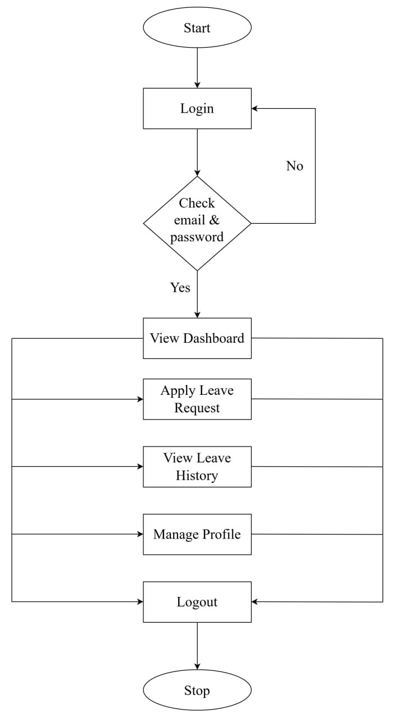
Figure 3. 1 System Flow Diagram for Staff

3.1.2 System Flow Diagram for Department Head
The Department Head accesses a dedicated workflow menu, as illustrated in Figure 3.2. From here, the Department Head can view the dashboard, apply for leave requests, review pending leave applications, verify the staff member's leave history, manage profile, view reports, and choose to recommend or not recommend each request. If the request is not recommended, the system automatically dispatches a not-recommended notification back to the staff member. Conversely, if the request is recommended, it is forwarded to the System Administrator for final approval.
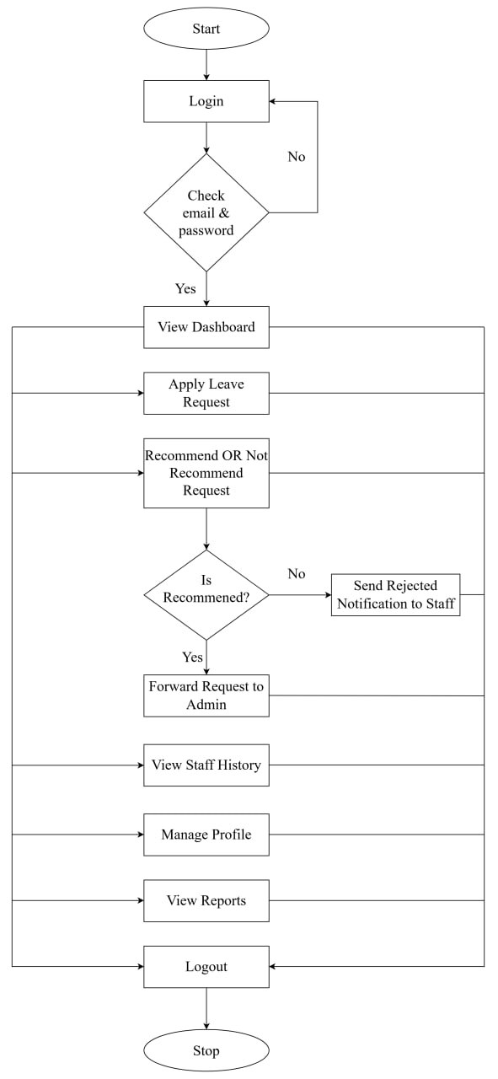
Figure 3. 2 System Flow Diagram for Department Head

The system then processes these approval actions to automatically recalculate and update the staff's leave balances in real time. Finalized leave records and approval histories are securely stored in the database, allowing Department Heads and Administrators to review or export them as administrative summary reports. This structured flow ensures a logical sequence of institutional operations, minimizes administrative delays, and maintains system efficiency throughout the staff leave lifecycle.

3.2 Use Case Diagram
A use case diagram is a type of behavioral diagram defined by the Unified Modeling Language (UML). Its primary purpose is to visualize the functional requirements of a system, including the relationships between actors (users or other systems) and the system itself.
Key Components of a Use Case Diagram are:
Actors: Represent the users or other systems that interact with the system. Actors are typically depicted as stick figures.
Use Cases: Represent the functionalities or services provided by the system to the actors. They are usually depicted as ovals and contain the actions or events that actors can perform or that the system supports.
System Boundary: Encloses all the use cases and is represented by a rectangle. It defines the scope of the system, differentiating what is inside (part of the system) and what is outside (external to the system).
Relationships: Show the interactions and dependencies between actors and use cases, or between use cases themselves. The main types of relationships include:
- Association: A line connecting an actor to a use case, indicating that the actor participates in that use case.
- Include: A dashed arrow from one use case to another, indicating that the behavior of the included use case is always part of the base use case.
- Extend: A dashed arrow with an open arrowhead from one use case to another, indicating that the behavior of the extended use case may be included under certain conditions.
- Generalization: Represents inheritance between use cases or actors, with a solid line and a closed arrowhead pointing to the more general use case or actor.
In Figure 3.3 and Figure 3.4, the use case diagrams illustrate the interactions between the system and its primary user roles: staff and department head. The system provides structured, role-based access control to streamline leave applications and evaluation workflows within the university. These diagrams provide a high-level overview of main operations that each actor can perform within the system.
Actors:
- Staff : General university staffs who submit leave applications, check their leave history, and view remaining leave balances.
- Department Head : Departmental administrators responsible for evaluating and processing staff leave requests while also having access to personal leave functionalities and report generation.

3.2.1 Use Case Diagram for Staff
The staff role represents general university personnel responsible for managing personal leave applications and tracking their approval statuses. The functional capabilities provided for the Staff actor are defined as follows:
- Login: Authenticates staff members using unique credentials to grant secure access to role-specific system capabilities.
- Dashboard: Features an embedded <<include>> relationship to View Leave Information, presenting real-time summary statistics, eligible leave balances, and current application statuses.
- Manage Profile: Enables users to maintain and update their personal user details and contact credentials.
- Request Leave: Serves as a primary parent use case that incorporates two mandatory <<include>> functional components:
- Apply Leave: Allows staff to create and submit new leave applications by specifying leave types, duration, and supporting reasons.
- Check Leave History: Provides an audit trail of previous leave applications alongside real-time tracking of pending requests.
- Logout: Securely terminates the active user session to prevent unauthorized system access.
The interactions, functional scope, and structural boundaries for the Staff user role are depicted in Figure 3.3.
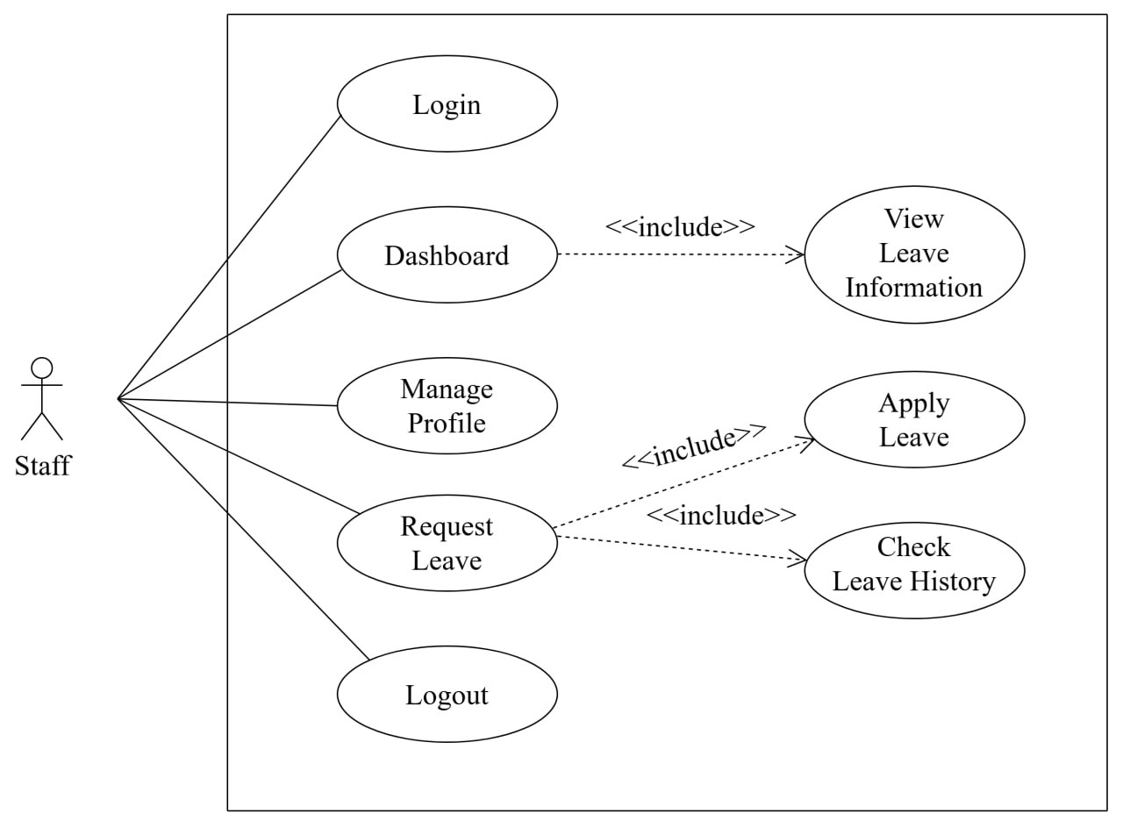
Figure 3. 3 Use Case Diagram for Staff

3.2.2 Use Case Diagram for Department Head
The Department Head role encompasses all base staff functionalities while extending access to administrative evaluation and recommendation workflows for departmental staff. The specific use cases designated for the Department Head actor include:
- Login: Grants authenticated access with elevated supervisory permissions.
- Dashboard: Includes View Leave Information to aggregate and display high-level departmental leave statistics alongside personal leave balances.
- Manage Profile: Allows Department Heads to review and modify personal user profile information.
- Request Leave: Facilitates the submission and tracking of personal leave requests through included Apply Leave and Check Leave History operations.
- Manage Staff Request: Represents the core departmental assessment workflow, which directly includes two conditional evaluation options:
  - Recommend Request: Endorses the staff member's leave application and forwards it to the System Administrator for final authorization.
  - Not Recommend Request: Declines the leave application at the departmental level and automatically triggers a notification to the applicant.
- Generate Reports: Includes a <<include>> relationship to Download PDF for
exporting departmental leave reports in PDF format.
- Logout: Ends the active session and logs the user out of the system securely.
The operational workflow and actor-use case relationships for the Department Head are illustrated in Figure 3.4.

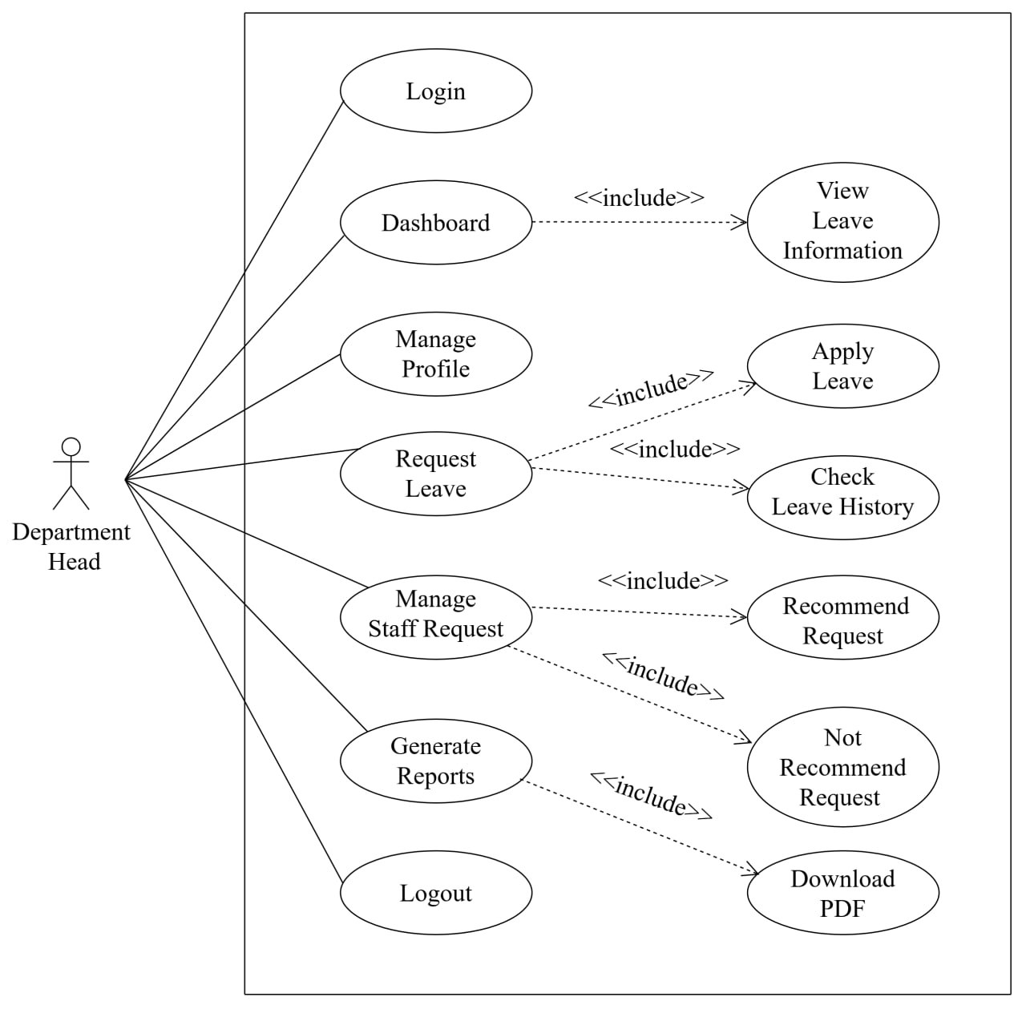
Figure 3. 4 Use Case Diagram for Department Head

The use case model provides secure, role-based access for each user according to their responsibilities. General Staff can view their leave information, check leave balances, submit leave applications, and download leave reports. Department Heads can view department staff, monitor leave activities, and review applications by providing recommendations or non-recommendations, and export summary reports. Administrators manage staff accounts, departments, leave types, leave balances, and final approval decisions. By clearly separating user responsibilities, the system reduces unauthorized access and errors while improving data accuracy, transparency, and administrative efficiency.

3.3 Entity Relationship Diagram (ERD)
An Entity Relationship Diagram (ERD) also known as an entity relationship model, is a graphical representation that depicts relationships among people, objects, places, concepts or events within an Information Technology (IT) system. An ERD uses data modeling techniques that can help define business processes and serve as the foundation for a relational database). An ERD attribute can be denoted as a primary key, which identifies a unique attribute, or a foreign key, which can be assigned to multiple attributes. A cardinality notation can then define the attributes of the relationship between the entities.
The three main cardinalities are:
- A one-to-one relationship (1:1): A one-to-one relationship is a link between the information in two tables, where each record in each table only appears once. For example, if each customer in a database is associated with one mailing address. `
- A one-to-many relationship (1:M): This is where a row from one table can have multiple matching rows in another table this relationship is defined as a one-to-many relationship. This type of relationship can be created using Primary key - Foreign key relationship. For example, a single customer might place an order for multiple products. The customer is associated with multiple entities, but all those entities have a single connection back to the same customer.
- A many-to-many relationship (M: N): The key to resolve min relationships is to separate the two entities and create two one-to-many (1: n) relationships between them with a third intersect entity. For example, at a company where all call center agents work with multiple customers, each agent is associated with multiple customers, and multiple customers might also be associated with multiple agents.
The database of the Leave Management System consists of five main entities: Departments, Users, Leave Types, Leave Requests, and Leave Balance. Figure 3.3 illustrates the relationships among these entities, which are designed to manage staff information, department details, leave types, leave applications, and leave balances efficiently. The Users entity is connected to Departments and Leave Requests, while Leave Types and Leave Balance are linked to users and leave requests to maintain accurate leave records. This database structure ensures data integrity, reduces redundancy, and supports efficient leave tracking, request processing, and report generation within the system.

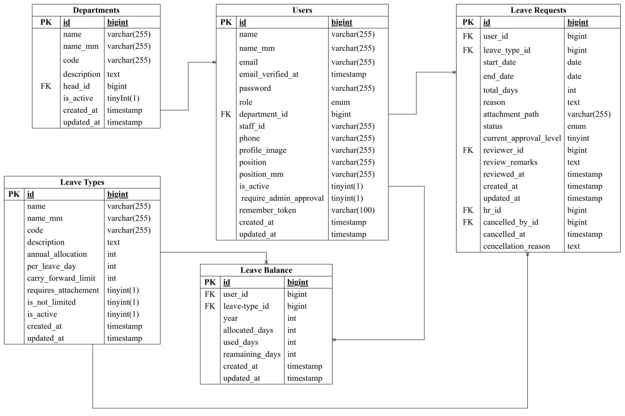
Figure 3. 5 ER Diagram
The Departments table stores information about each department with fields such as id, name, name_mm, code, description, head_id, and is_active. The id is the primary key, while head_id is a foreign key that references the Users table. This table allows the system to organize staff according to their respective departments.
The Users table contains user and staff information such as id, name, name_mm, email, email_verified_at, password, role, department_id, staff_id, phone, profile_image, position, position_mm, is_active, require_admin_approval, remember_ token, created_at, and updated_at. The id is the primary key, and department_id is a foreign key referencing the Departments table. This table stores the personal, account, and role-related information of system users.
The Leave Types table stores information about the different types of leave available in the system. It includes fields such as id, name, name_mm, code, description, annual_allocation, per_leave_day, carry_forward_limit, requires_ attachment, is_not_limited, is_active, created_at, and updated_at. The id is the primary key. This table allows the system to define and manage different leave policies and entitlements.
The Leave Requests table records leave applications submitted by users. It contains fields such as id, user_id, leave_type_id, start_date, end_date, total_days, reason, attachment_path, status, current_approval_level, reviewer_id, review_remarks, reviewed_at, created_at, updated_at, hr_id, cancelled_by_id, cancelled_at, and cancellation_reason. The id is the primary key, while user_id, leave_type_id, reviewer_id, hr_id, and cancelled_by_id are foreign keys. This table allows the system to track leave applications, their approval status, reviewers, and cancellation information.
The Leave Balance table stores the leave balance information of each user for different leave types and years. It includes fields such as id, user_id, leave_type_id, year, allocated_days, used_days, remaining_days, created_at, and updated_at. The id is the primary key, while user_id and leave_type_id are foreign keys referencing the Users and Leave Types tables. This table helps the system track allocated, used, and remaining leave days for each user.
Overall, the ER diagram represents a structured Leave Management System in which Users are connected to Departments, Leave Requests, and Leave Balance, while Leave Types are associated with leave requests and leave balances. These relationships ensure that staff information, department details, leave applications, leave policies, and leave balances are properly linked and maintained. The database structure supports data integrity, efficient leave processing, accurate leave tracking, and effective management of employee leave records.

3.4 Data Dictionary
A data dictionary serves an important purpose of providing centralized and structured documentation of your organization’s data assets. It describes the meaning, relationships, and usage of data elements, making it easier for users to understand and utilize the available data. A data dictionary provides centralized and structured documentation of an organization’s data assets. These are important in database management, data modeling, and software development.
It helps to ensure consistency, clarity, and efficient data management. It helps to ensure that everyone in the organization understands the data, how it should be used, and how it should be managed. It provides standard definitions for data elements, ensuring that everyone in the organization understands and uses data in the same way.
By defining data types, lengths, and constraints, a data dictionary helps maintain high data quality and integrity. It serves as a reference document that improves communication among stakeholders, including developers, database administrators, and business users. New team members can quickly understand the database structure and data usage by referring to the data dictionary. A data dictionary is a collection of metadata such as object name, data type, size, classification, and relationships with other data assets. A data dictionary acts as a reference guide on a dataset.
The Users table stores information related to all users of the Leave Management System, including administrators, department heads, and staff members as shown in Table 3.1. This table contains login credentials, personal information, department details, and user roles. The primary key is id, which uniquely identifies each user. The department _id is a foreign key that links each user to the corresponding department.
Table 3. 1 Users Table
Column Name | Data Type | Key Constraints
User_ID | BIGINT | Primary Key
Username | Varchar (255) | Not Null
Username_mm | Varchar (255) | Not Null
Email | Varchar (255) | Not Null, Unique
Password | Varchar (255) | Not Null
Role | ENUM | Not Null
Department_ID | BIGINT | Foreign Key
Staff_ID | Varchar (255) | Not Null
Phone | Varchar(255) | Null
Profile_Image | Varchar(255) | Null
Position | Varchar(255) | Not Null
Position_mm | Varchar(255) | Null
Is_Active | TinyInt(1) | Not Null
Require_Admin_ Approval | TinyInt(1) | Not Nul
Remember_Token | Varchar(100) | Null
Created_At | Timestamp | Not Null
Updated_At | Timestamp | Not Null
The Departments table stores information about the departments in the Leave Management System as shown in Table 3.2. It contains department names, department codes, descriptions, and information about the department head. The primary key is id, which uniquely identifies each department. The head _id is a foreign key that references the Users table and identifies the user assigned as the department head. The Departments table stores information about the departments in the Leave Management System. It contains department names, department codes, descriptions, and information about the department head. The primary key is id, which uniquely identifies each department. The head _id is a foreign key that references the Users table and identifies the user assigned as the department head.
Table 3. 2 Department Table
Column Name | Data Type | Key Constraints
Department_ID | BIGINT | Primary Key
Department_Name | Varchar (255) | Not Null
Department_Name_mm | Varchar (255) | Not Null
Code | Varchar (255) | Not Null, Unique
Description | Text | Null
Department_Head_id | BIGINT | Foreign Key
Is_Active | TinyInt(1) | Not Null
Created_At | Timestamp | Not Null
Updated_At | Timestamp | Not Null

The Leave Types table stores information about the different types of leave available in the Leave Management System as shown in Table 3.3. It contains the leave type name, code, description, leave allocation, carry-forward limit, and attachment requirements. The primary key is id, which uniquely identifies each leave type. The is_not _limited field indicates whether the leave type has no specific limitation, while is _active indicates whether the leave type is currently available for use.
Table 3. 3 Leave Types Table
Column Name | Data Type | Key Constraints
Leave_Type_ID | BIGINT | Primary Key
Leave_Type_Name | Varchar (255) | Not Null
Leave_Type_Name_mm | Varchar (BIGINT255) | Not Null
Code | Varchar (255) | Unique, Not Null
Description | Text | Null
Annual_Allocation | Int | Not Null
Per_Leave_Days | Int | Not Null
Carry_Forward_Limit | Int | Not Null
Requires_Attachment | TinyInt(1) | Not Null
Is_Not_Limited | TinyInt(1) | Not Null
Is_Active | TinyInt(1) | Not Null
Created_At | Timestamp | Not Null
Updated_At | Timestamp | Not Null

The Leave Requests table stores information about leave applications submitted by users in the Leave Management System as shown in Table 3.4.It contains the requested leave type, leave duration, reason, application status, approval level, reviewer information, and cancellation details. The primary key is id, which uniquely identifies each leave request. The user _id and leave _type _id are foreign keys referencing the Users and Leave Types tables, while reviewer _id, hr _id, and cancelled _by _id are foreign keys referencing the Users table. This table allows the system to track the complete leave request and approval process.
Table 3. 4 Leave Request Table
Column Name | Data Type | Key Constraint
Leave_Request_ID | BIGINT | Primary Key
User_ID | BIGINT | Foreign Key
Leave_Type_ID | BIGINT | Foreign Key
Start_Date | DATE | Not Null
End_Date | DATE | Not Null
Total_Days | INT | Not Null
Reason | TEXT | Not Null
Attachment_Path | Varchar (255) | Null
Status | ENUM | Not Null
Current_Approval_Level | TinyInt(1) | Not Null
Reviewer_ID | BIGINT | Foreign Key
Review_Remarks | TEXT | Null
Created_At | Timestamp | Not Null
Updated_At | Timestamp | Not Null
Hr_ID | BIGINT | Foreign Key
Cancelled_By_ID | BIGINT | Foreign Key
Cancelled_At | Timestamp | Null
Cancellation_Reason | TEXT | Null

The Leave Balance table stores information about the leave entitlement and usage of each user for different types of leave as shown in Table 3.5.It contains the allocated leave days, used leave days, and remaining leave days for each year. The primary key is id, which uniquely identifies each leave balance record. The user _id and leave _type _id are foreign keys referencing the Users and Leave Types tables. This table enables the system to accurately track each user's leave balance and remaining leave entitlement.
Table 3. 5 Leave Balance Table
Column Name | Data Type | Key Constraint
Leave_Balance_ID | BIGINT | Primary Key
User_ID | BIGINT | Foreign Key
Leave_Type_ID | BIGINT | Foreign Key
Year | INT | Not Null
Allocated_Days | INT | Not Null
Used_Days | INT | Not Null
Remaining_Days | INT | Not Null
Created_At | Timestamp | Not Null
Updated_At | Timestamp | Not Null

CHAPTER 4

SYSTEM IMPLEMENTATION
The Leave Management System (LMS) is developed to provide a streamlined and efficient method for managing staff leave records and approval workflows within an organization. The system is implemented as a web-based platform using modern technologies, including PHP with the Laravel Framework for robust backend logic and business rules, modern front-end web technologies (HTML, CSS, and JavaScript) for responsive and user-friendly interface design, and MySQL as the relational database management system for secure data storage. The application ensures seamless system operations, effective data handling, and reliable performance across different user roles.
The implementation ensures that authenticated users including General Staff, Department Heads, Administrators, and System Admins can interact with the system based on their assigned roles. Staff members can submit leave applications by designating a substitute staff member for duty handover, monitor request statues, and generate individual leave history reports. Department Heads can review applicatons from their respective departments to provide recommendations, and access department-level leave reports. Administrators can perform final approvals, manage user profiles, department configurations, leave types, and generate administrative summary reports. System Administrators oversee system privileges and manage administrator accounts. The focus is on providing an intuitive user interface, accurate data validation, role-based authorization, and automated leave balance recalculations across all organizational operations.

4.1 System Requirements
The requirements for the implementation and development of the proposed Leave Management System are divided into two main categories: software requirements and hardware requirements. These requirements provide the necessary environment for developing, testing, and operating the system effectively.
The software requirements for the development and implementation of the system are as follows:
- Operating System: Windows 10/11, macOS, or Linux.
- Visual Studio Code (VS Code): Used as the primary source-code editor for developing and managing the system.
- Node.js and npm: Used for managing JavaScript packages and front-end dependencies. Yarn can also be used as an alternative package manager.
- MySQL: A relational database management system used to store, organize, and manage system data.
- Laravel: A PHP web application framework used to develop a secure, efficient, and maintainable web-based system.
- Web Technologies: Laravel, PHP, HTML, CSS, JavaScript, and Tailwind CSS are used for developing the system's back-end and front-end components.
- Web Browsers: Google Chrome, Microsoft Edge, Mozilla Firefox, or other modern web browsers are required for testing and accessing the system.
The hardware requirements for developing and operating the system are as follows:
    - Processor: Intel Core i5 or equivalent processor.
    - Memory (RAM): 8 GB or higher.
    - Storage: At least 256 GB of available SSD storage.
    - Operating System Architecture: A 64-bit operating system with an x64-based processor is recommended for better system performance.
    - Network: A reliable internet connection is required for downloading software dependencies, system updates, and accessing online development resources.

4.2 User Interface Design
The system features a clean, responsive, and user-friendly interface built with modern web components and custom CSS styles. All modules follow a consistent structure, utilizing form-based interactions and structured table views for managing actions such as submitting, approving, rejecting, and deleting leave requests or user records. Modal windows and confirmation prompts are incorporated where necessary to provide a focused experience and enhance usability. The design supports both English and Myanmar languages, ensuring accessibility for all administrative and academic staff. Security and access control were prioritized to ensure reliable and restricted usage according to assigned user roles. In addition, the system provides clear navigation and organized menus, allowing users to access required functions efficiently.

4.2.1 Design for Home Page
The Home page serves as the public landing interface for the Leave Management System at Computer University (Hinthada). As shown in Figure 4.1, the layout features a modern user interface with institutional branding, a Myanmar/English language toggle, and a primary login access button. A clear Call-to-Action (CTA) button is integrated to guide users directly to the login portal. Additionally, the hero section displays a brief system description alongside clean typography and responsive design elements. This structured layout ensures an intuitive navigation experience for users accessing the platform across various devices.
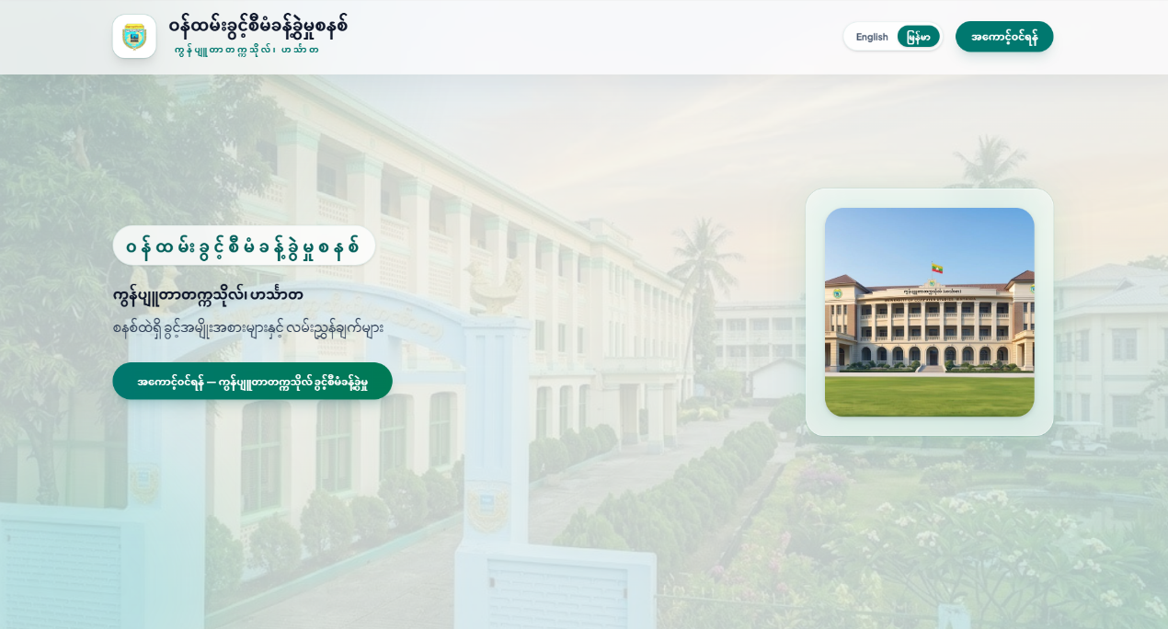
Figure 4. 1 Home Page Interface

4.2.2 Design for Login Form
The Login page serves as the primary authentication interface for the Leave Management System. As shown in Figure 4.1, the layout features a clean, centralized form structure layered over an institutional background image, enforcing secure, role-based entry for Staff, Department Heads, and Administrators. The user interface incorporates a role selection dropdown alongside input fields requiring user credentials, specifically an institutional email address and a password. Additional usability features, such as a "Remember me" checkbox for session persistence and a "Forgot password?" recovery link, are integrated into the design. Upon clicking the "Sign In" button, the system authenticates the credentials against the database and redirects the user to their respective dashboard interface. A navigation button is also provided to allow users to return to the landing page.

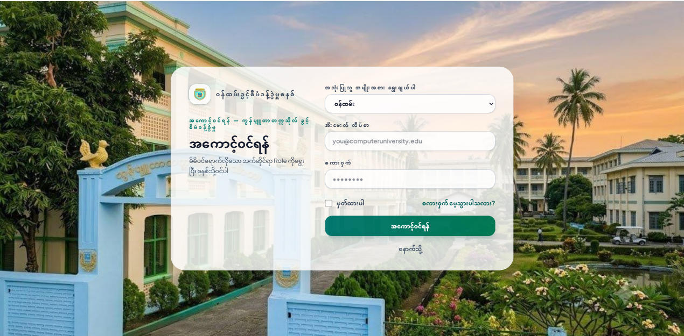
Figure 4. 2 Login Form

4.2.3 Design for Staff Dashboard
The Staff Dashboard page serves as the main personal overview interface for staff members upon logging into the system, as illustrated in Figure 4.3. The layout features a top navigation bar with institutional branding, language toggle, and notifications, alongside a persistent sidebar for seamless access to navigation modules and logout options. The upper central section displays real-time metrics for pending and approved applications. Below, the main display organizes leave balances across categories including Casual, Medical, Earned, Maternity, Study, and Emergency Leave into intuitive visual summary cards. By clearly structuring allowance counts alongside non-limited leave types, the dashboard enables staff members to monitor their leave entitlements efficiently.
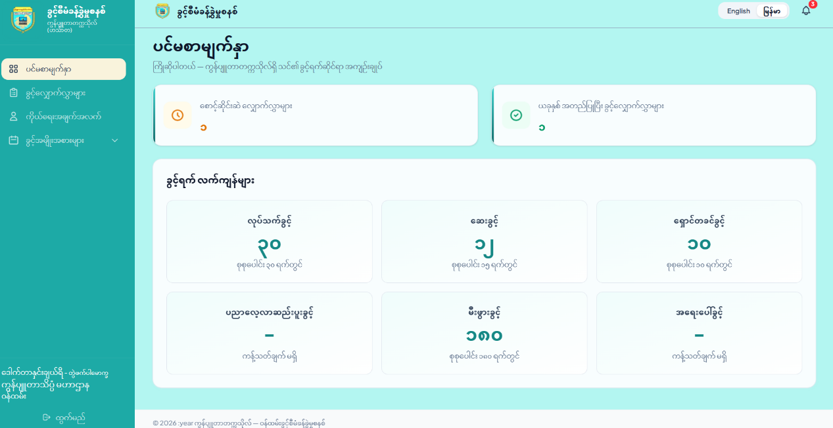
Figure 4. 3 Staff Dashboard Interface

4.2.4 Design for Leave Requests Information
The Leave Requests Information page provides staff members with a comprehensive interface to view, filter, and manage their submitted leave applications, as illustrated in Figure 4.4. The top section features interactive filter controls by leave type, start date, and end date, alongside a prominent "New Request" button for fast application submission. Below, a structured table displays key details—including applicant name, leave type, academic position, department, requested date ranges, total days, supporting attachments, current status indicators (such as Pending, Approved, and Cancelled), and action options to view details or cancel pending requests. This organized layout streamline searching, status tracking, and record management while minimizing administrative lookup time.
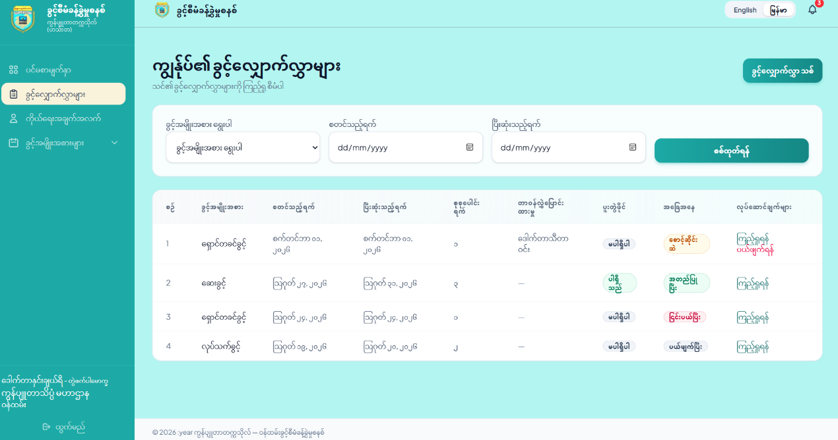
Figure 4. 4 Leave Request Interface

4.2.5 Design for Leave Request Form
The Leave Request Page provides staff members with a structured interface for submitting leave requests, as illustrated in Figure 4.5. The centered input form allows users to select a leave category, specify date ranges via interactive date pickers, select a substitute staff member for duty handover, and provide reasons for the leave. For verification, a file upload component supports attachments (PDF, JPG, or PNG up to 2MB). With real-time form validation and clear action controls, the system ensures accurate data entry before forwarding requests to the Department Head for recommendation.
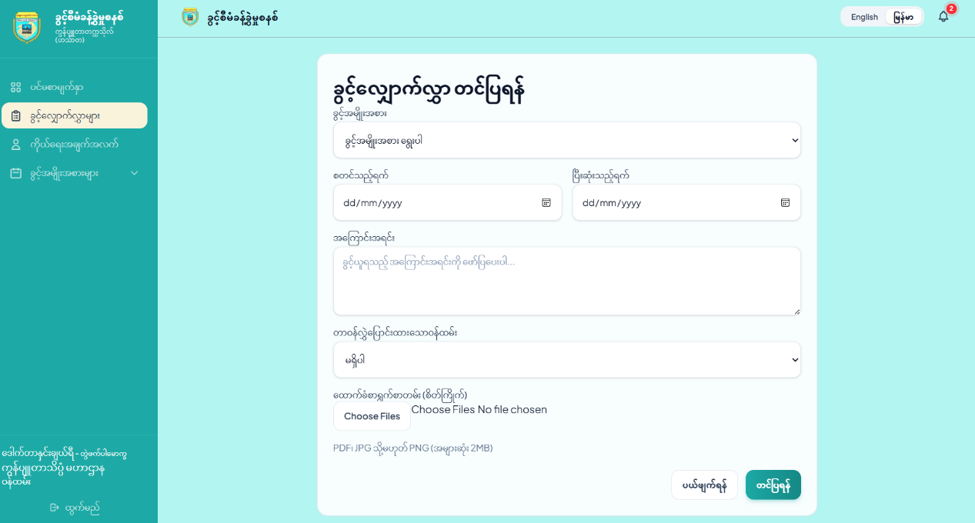
Figure 4. 5 Leave Request Form

4.2.6 Design for Profile Page
The Profile page enables staff members to view and manage personal account details and security credentials within a unified interface, as shown in Figure 4.6. The layout is organized into a clean two-column structure: the left section handles personal information including photo upload, full name, position, email, and phone number, while the right section features a dedicated password update form. Real-time system validation and clear action buttons (Save Changes and Cancel) ensure profile updates are processed accurately and securely, providing an efficient user experience.
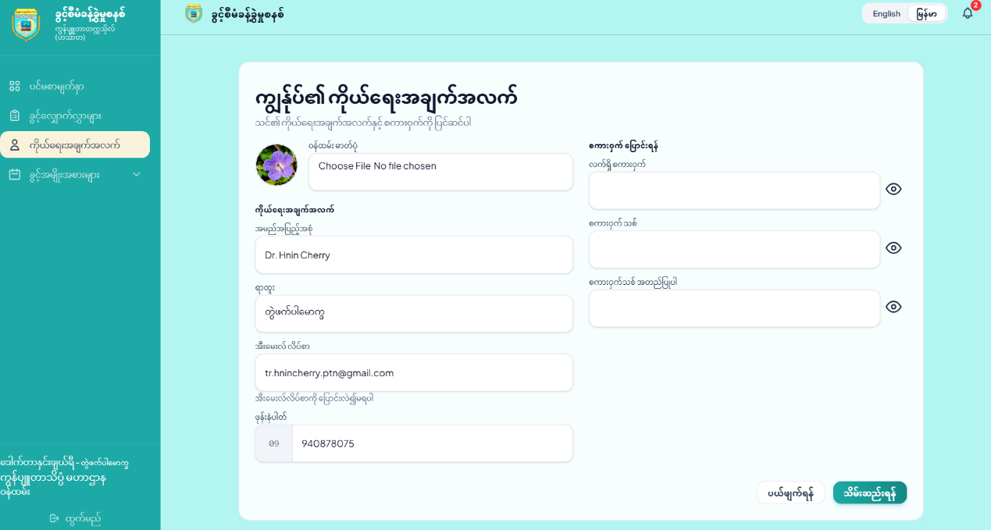
Figure 4. 6 Profile Page Layout

4.2.7 Design for Department Head Dashboard Page
The Department Head Dashboard page serves as the primary management overview interface to oversee departmental leave activities, as illustrated in Figure 4.8. The upper section displays key metrics through three summary cards: pending approval requests, total department staff count, and verified monthly leaves. Below, the central display tracks the Department Head's personal leave balances across various categories, including Casual, Medical, Maternity, and Study Leave. Additionally, a persistent sidebar provides structured navigation to manage department staff details, process pending leave recommendations, access reports, and manage profile settings.
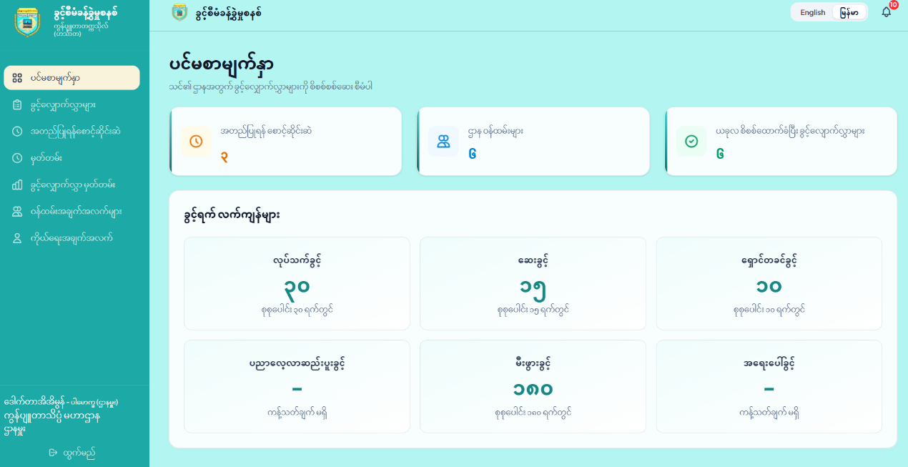
Figure 4. 7 Department Head Dashboard Page

4.2.8 Design for Department Head Leave Requests Information
The Department Head Leave Requests page provides department heads with a structured interface to view, filter, and track their personal leave applications, as illustrated in Figure 4.8. The upper section features interactive search controls by leave type, start date, and end date, alongside a prominent "New Request" button for initiating leave applications. Below, a comprehensive table records key details—including leave type, date ranges, total requested days, substitute staff designations, attachments, and status indicators (such as Pending and Approved)—with action options to view application details or cancel pending requests. Furthermore, integrated real-time status updates allow users to monitor approval progress instantly. This organized layout minimizes search time and enables efficient tracking of personal leave requests.
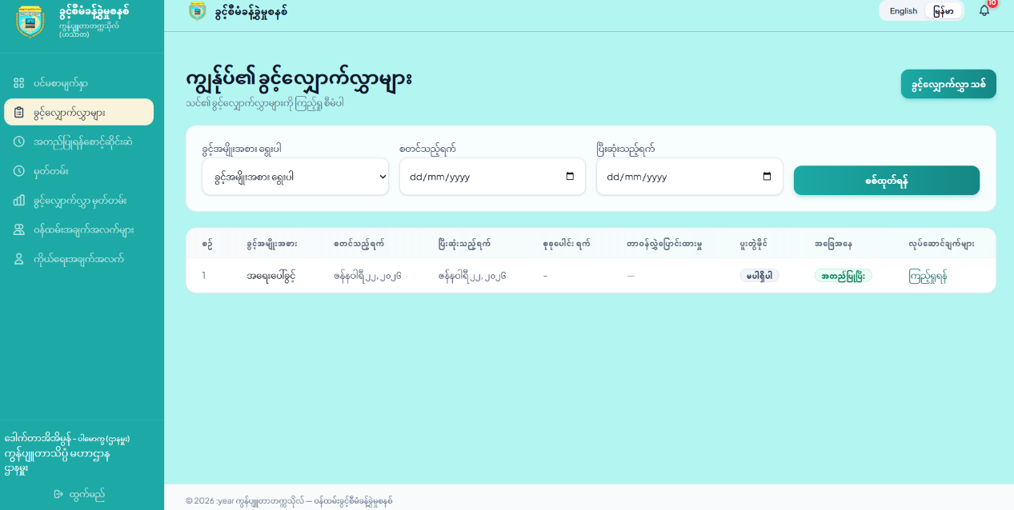
Figure 4. 8 Department Head Leave Requests Information Interface

4.2.9 Design for Department Head Leave Request
The Department Head Leave Application page provides department heads with a structured interface for submitting their own leave requests, as shown in Figure 4.9. The centered input form allows users to select a leave type, set start and end dates, select a substitute staff member for duty handover, and state the reason for leave. It also includes an optional file upload component supporting PDF, JPG, or PNG files up to 2MB for required documentation. Supported by real-time validation and action controls (Submit and Cancel), the page ensures accurate data entry before forwarding the request to the Administrator for final evaluation.
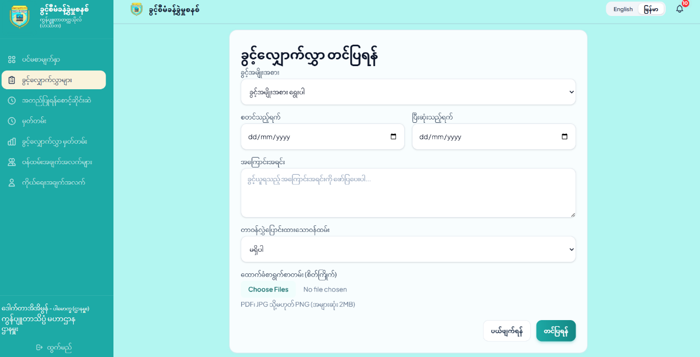
Figure 4. 9 Department Head Leave Request Form

4.2.10 Design for Pending Leave Approvals Page
The Pending Leave Approvals page serves as the primary evaluation interface for Department Heads to review and recommend leave applications submitted by departmental staff, as illustrated in Figure 4.10. The upper section features interactive search controls by staff name or leave category to quickly locate pending requests. The main content area displays application cards summarizing key details—including applicant name, staff ID, leave type, date range, total days, duty handover staff, submission timestamp, and pending status. Department Heads can inspect attachments and provide formal recommendations (Recommend or Not Recommend) directly through integrated action controls, forwarding requests to the Administrator for final approval.
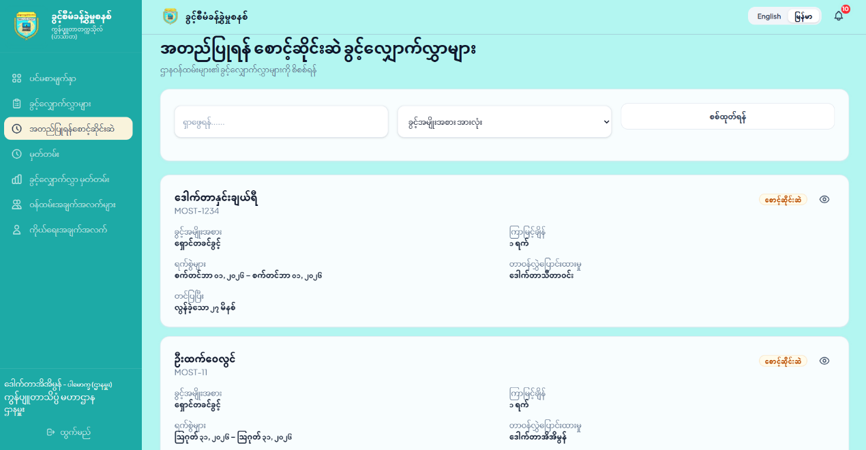
Figure 4. 10 Pending Leave Approvals Page Design

4.2.11 Design for Leave Approval History
The Leave Approval History page provides a comprehensive record of reviewed leave applications within the department, as illustrated in Figure 4.11. The main area presents a structured tabular ledger displaying key details—including applicant name, leave type, academic position, department, date ranges, total days, attachments, recommendation status, and evaluator details. Interactive filtering controls allow Department Heads to locate historical entries and track recommendation outcomes. By maintaining an organized audit trail, this interface enhances transparency, accountability, and reporting efficiency across the department.
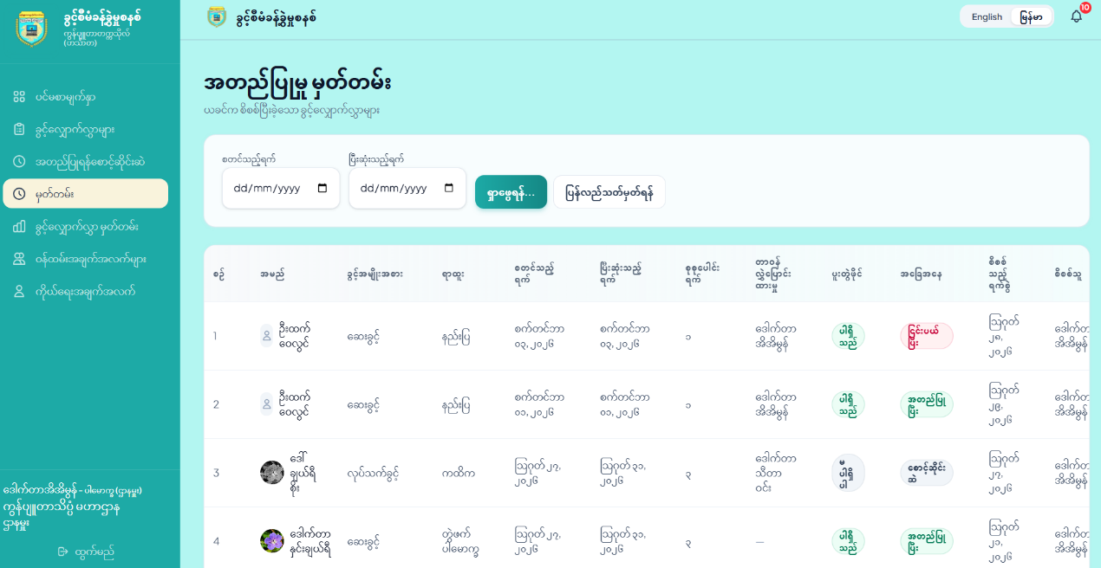
Figure 4. 11 Approval History Interface

4.2.12 Design for Staff Information
The Staff Information page serves as a centralized directory for Department Heads to view and oversee staff information, as illustrated in Figure 4.12. The structured tabular layout displays personnel details across multiple columns, including serial number, full name, staff ID, email, academic position, phone number, system role (e.g., Staff or Department Head), and account status (Active/Inactive). By presenting these details clearly, the interface improves information accessibility, supports effective communication, and allows Department Heads to review staff records efficiently without navigating multiple pages.
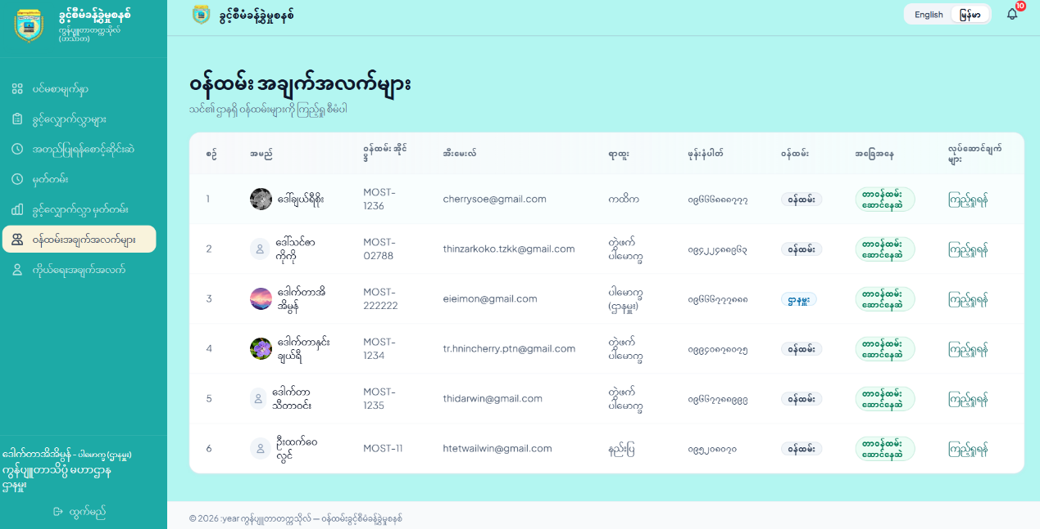
Figure 4. 12 Staff Information Page

4.2.13 Design for Department Head Profile
The Department Head Profile page enables department heads to view and update their personal information and credentials, as illustrated in Figure 4.13. The two-column layout features personal details and profile photo management on the left, alongside password update controls requiring authentication on the right. Integrated data validation and action buttons allow users to update their credentials securely within a single view. Furthermore, this page ensures user privacy by validating security parameters before processing modifications. Interactive alert messages display real-time feedback upon saving changes, preventing unauthorized modifications and improving administrative convenience.
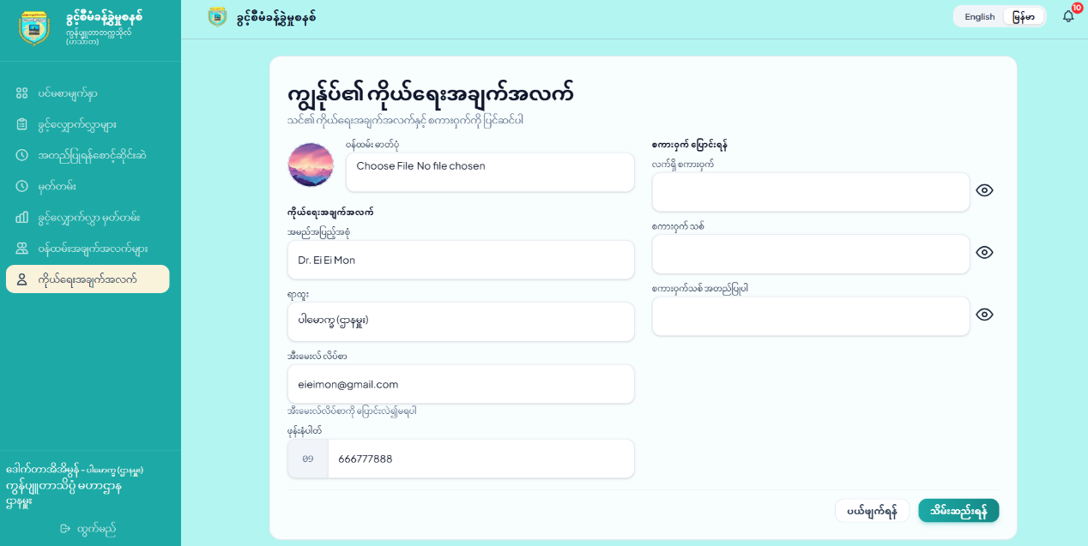
Figure 4. 13 Department Head Profile Interface

4.2.14 Design for Department Leave Report Interface
The Department Leave Report Interface enables authorized management to monitor, analyze, and generate comprehensive leave statistics for staff members within their designated department, as presented in Figure 4.14. The layout features custom date-range filtering options alongside export capabilities in both PDF and Excel (XLSX) formats. Visual bar charts and structured data tables categorize total leave applications by leave types, facilitating official departmental record-keeping, administrative tracking, and decision-making processes. In addition, the dynamic data display updates instantly based on selected search parameters, allowing department heads to review leave duration trends, evaluate departmental attendance coverage, and maintain seamless administrative operations.
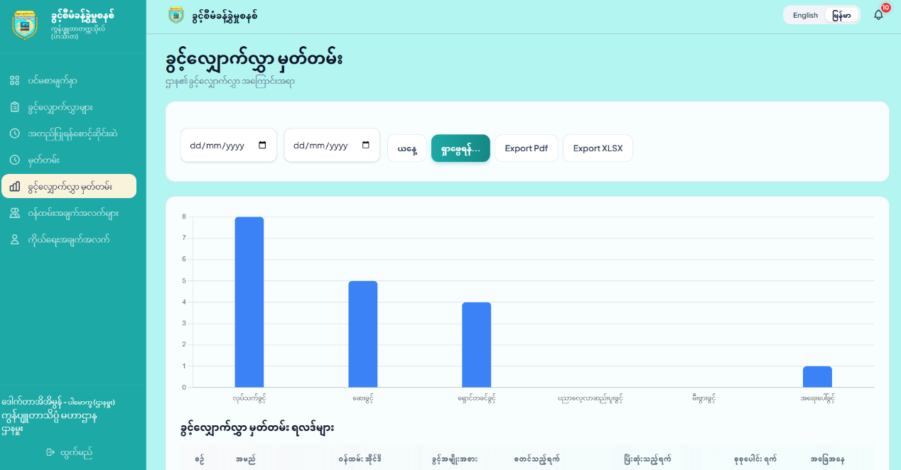
Figure 4. 14 Department Leave Report Interface

4.3 Database Management System Implementation
The Leave Management System utilizes MySQL as its relational database management system, integrated seamlessly with the Laravel ORM framework. Database authentication and persistence are established through configured environment credentials to support secure transaction processing across system entities.
The users table serves as the foundational identity structure within the system, managing account credentials, administrative roles, departmental affiliations, and employment attributes for all academic and administrative staff. The primary key is id.
Schema::create('users', function (Blueprint $table) {
$table->id();
$table->string('name');
$table->string('name_mm')->nullable();
$table->string('email')->unique();
$table->timestamp('email_verified_at')->nullable();
$table->string('password');
$table->enum('role', ['staff', 'head', 'admin', 'hr']);
$table->foreignId('department_id')->constrained('departments');
$table->string('staff_id')->unique();
$table->string('phone')->nullable();
$table->string('profile_image')->nullable();
$table->string('position');
$table->string('position_mm')->nullable();
$table->boolean('is_active')->default(true);
$table->boolean('require_admin_approval')->default(false);
$table->rememberToken();
$table->timestamps();
});
The "SELECT" statement is utilized to retrieve structured records from the database table. In the application controller, Laravel Eloquent and DataTables services construct these queries dynamically to output filtered user data for administrative management interfaces. The general SQL syntax is: SELECT * FROM table_name WHERE condition;
public function index(Request $request)
{
if ($request->ajax()) {
return $this->dataTable();
}
return view('backend.users.index');
}
private function dataTable()
{
$query = User::with('department')->query();
return DataTables::of($query)
->editColumn('is_active', function ($user) {
return $user->is_active ? 'Active' : 'Inactive';
})
->addColumn('action', function ($user) {
return view('backend.action.user_action', ['user' => $user]);
})
->editColumn('created_at', function ($data) {
return Carbon::parse($data->created_at)->format('d-M-Y H:i:s');
})
->rawColumns(['action'])
->make(true);
}
When registering a new user or staff record into the system, an "INSERT" operation persists validated input attributes into the table. The general SQL syntax is: INSERT INTO table_name (column1, column2, ...) VALUES (value1, value2, ...);
public function create()
{
$departments = Department::all();
return view('backend.users.create', compact('departments'));
}
public function store(StoreUserRequest $request)
{
$attributes = $request->validated();
$attributes['password'] = Hash::make($request->password);

User::create($attributes);
return redirect()->route('users.index')->with('success', 'User account successfully created!');
}
Existing records within the user table are modified through the "UPDATE" statement upon submitting updated profile attributes or administrative configurations. The general SQL syntax is: UPDATE table_name SET column1=value1, column2=value2 WHERE condition;
public function edit(User $user)
{
$departments = Department::all();
return view('backend.users.edit', compact('user', 'departments'));}
public function update(UpdateUserRequest $request, $id)
{
$user = User::findOrFail($id);
$attributes = $request->validated();

if ($request->filled('password')) {
$attributes['password'] = Hash::make($request->password);
} else {
unset($attributes['password']);
}
$user->update($attributes);
return redirect()->route('users.index')->with('success', 'User details successfully updated!');
}
The "DELETE" query statement is invoked to purge obsolete or revoked user records from the database instance. The general SQL syntax is: DELETE FROM table_name WHERE condition;
public function destroy($id)
{
$user = User::findOrFail($id);
$user->delete();
return response()->json(['status' => 'success', 'message' => 'User account deleted successfully!']);
}

4.4 Hosting the Website
The Digital Leave System was deployed on an Ubuntu Linux virtual machine using NGINX, MySQL, PHP 8.4, and Laravel 12. The website was configured with the domain leave.ucsh.edu.mm and secured using HTTPS. The deployment process consisted of server preparation, database configuration, application deployment, environment configuration, web server configuration, file-upload configuration, and final system verification.

4.4.1 Server Preparation and Software Installation
The hosting server was prepared using an Ubuntu Linux virtual machine with sudo privileges and Internet connectivity. The system packages were updated before installing the software required to run the Laravel application.
sudo apt update && sudo apt upgrade -y
NGINX, Git, and Unzip were installed using the following command:
sudo apt install nginx git unzip -y
MySQL Server was installed to provide the database service:
sudo apt install mysql-server -y
PHP 8.4 and the extensions required by Laravel 12 were then installed:
sudo apt install php8.4-fpm php8.4-mysql php8.4-mbstring \
php8.4-xml php8.4-curl php8.4-zip php8.4-bcmath -y
Composer was installed as the PHP dependency manager for the Laravel application:
curl -sS https://getcomposer.org/installer | php
sudo mv composer.phar /usr/local/bin/composer

4.4.2 Database Configuration
A dedicated MySQL database was created for the Leave Management System. MySQL was accessed using:
sudo mysql -u root -p
The database and application-specific database user were created with the following SQL commands:
CREATE DATABASE ucsh_leave;
CREATE USER 'leaveuser'@'localhost'
IDENTIFIED BY '<DB_PASSWORD>';
GRANT ALL PRIVILEGES ON ucsh_leave.*
TO 'leaveuser'@'localhost';
FLUSH PRIVILEGES;
exit;
If an existing database backup was available, the data could be imported using:
sudo mysql -u root -p ucsh_leave < /path/to/ucsh_leave.sql
The dedicated database account allows the application to access only the database required by the Leave Management System.

4.4.3 Laravel Application Deployment
The Laravel application was deployed under the /var/www directory. First, the web directory was accessed:
cd /var/www
As shown in Figure 4.15, the project source code was cloned from the project's GitHub repository:
sudo git clone \
https://github.com/SuWaiHninUCSH/Leave.git \
leave_management_system
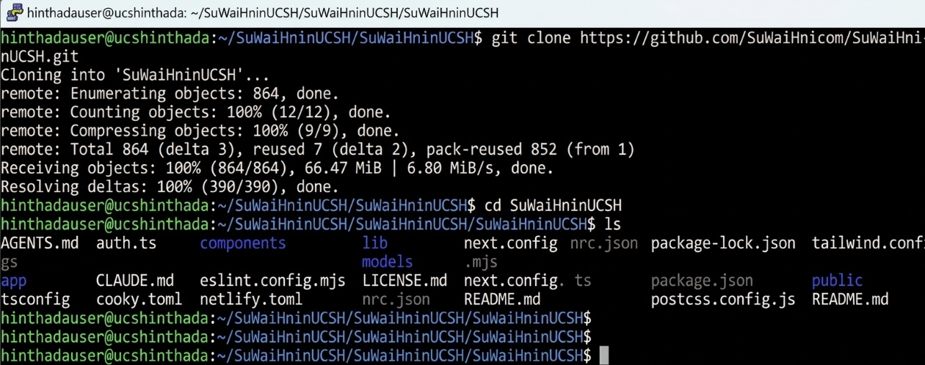
Figure 4. 15 Cloning the Leave Management System Repository
The ownership of the project directory was configured so that the deployment user could manage the application while allowing NGINX to access the required files:
sudo chown -R $USER:www-data /var/www/leave_management_system

The Leave Management System project directory was then accessed:
cd /var/www/leave_management_system

The production dependencies were installed using Composer:
composer install --optimize-autoloader --no-dev

The --no-dev option prevents development-only packages from being installed in the production environment, while --optimize-autoloader improves the performance of Laravel's class autoloader.

4.4.4 Laravel Environment Configuration
Laravel requires an environment configuration file to define application-specific settings such as the application URL, execution environment, and database connection. The default environment file was copied using:
cp .env.example .env

The Laravel application encryption key was generated with:
php artisan key:generate

The environment configuration file was then opened:
nano .env
The following production settings were configured:
APP_NAME=UCSH-Leave
APP_ENV=production
APP_DEBUG=false
APP_URL=https://leave.ucsh.edu.mm
DB_CONNECTION=mysql
DB_HOST=127.0.0.1
DB_PORT=3306
DB_DATABASE=ucsh_leave
DB_USERNAME=leaveuser
DB_PASSWORD=<DB_PASSWORD>

The application was configured to run in production mode, and debugging was disabled to prevent sensitive system information from being displayed to users. The database configuration was also connected to the MySQL database created for the system.

4.4.5 Directory and File Permissions
The Digital Catalogue System follows the standard Laravel project directory structure. The project contains the main Laravel directories, including app, bootstrap, config, database, public, resources, routes, storage, and vendor. The public directory serves as the entry point for the web application, while the storage directory is used by Laravel to store application-generated files, logs, cached data, and other runtime files.
To ensure that the Laravel application can create and modify the required runtime files, ownership of the project directory was assigned to the current deployment user and the NGINX web-server group using the following command:

sudo chown -R $USER:www-data /var/www/catalog_system

The required write permissions were then granted to the Laravel storage and bootstrap/cache directories:
sudo chmod -R 775 /var/www/catalog_system/storage
sudo chmod -R 775 /var/www/catalog_system/bootstrap/cache

These permissions allow Laravel and the NGINX/PHP-FPM processes to write application logs, cached configuration, compiled views, sessions, and other runtime data. The public directory contains the resources that are directly accessible through the web server, while the remaining application directories are kept outside the web-accessible document root to improve application security.

4.4.6 NGINX Web Server Configuration
NGINX was configured as the web server for the Leave Management System. A dedicated server configuration file was created using:
sudo nano /etc/nginx/sites-available/leave.ucsh.edu.mm
The following configuration was used:
server {
listen 443 ssl http2;
server_name leave.ucsh.edu.mm;
client_max_body_size 100M;
ssl_certificate /etc/ssl/certs/ucsh_fullchain.crt;
ssl_certificate_key /etc/ssl/private/ucsh.key;
ssl_protocols TLSv1.2 TLSv1.3;
ssl_prefer_server_ciphers on;
root /var/www/leave_managment_system/public;
index index.php index.html;
add_header X-Frame-Options "SAMEORIGIN" always;
add_header X-Content-Type-Options "nosniff" always;
add_header Referrer-Policy "strict-origin-when-cross-origin" always;
gzip on;
gzip_proxied any;
gzip_types text/plain application/json
application/javascript text/css;
gzip_comp_level 5;
location / { try_files $uri $uri/ /index.php?$query_string; }
location ~ \.php$ {
include snippets/fastcgi-php.conf;
fastcgi_pass unix:/run/php/php8.4-fpm.sock;
fastcgi_param SCRIPT_FILENAME $document_root$fastcgi_script_name;
include fastcgi_params;
}
access_log /var/log/nginx/leave_access.log;
error_log /var/log/nginx/leave_error.log;
}
server {
listen 80;
server_name leave.ucsh.edu.mm;
return 301 https://$host$request_uri;}

The configuration specifies the Laravel public directory as the web root and forwards PHP requests to PHP-FPM. HTTPS was enabled using the configured SSL certificate and private key. The HTTP server block redirects all HTTP requests to HTTPS, ensuring that users access the system through an encrypted connection.
The NGINX configuration was enabled with:
sudo ln -s \
/etc/nginx/sites-available/leave.ucsh.edu.mm \
/etc/nginx/sites-enabled/

The configuration was tested before restarting or reloading the server:
sudo nginx -t

4.4.7 PHP File Upload Configuration
Since the Leave Management System supports file uploads, PHP was configured to accept files up to 100 MB. The PHP-FPM configuration file was opened using:
sudo nano /etc/php/8.4/fpm/php.ini

The following settings were configured:
post_max_size = 100M
upload_max_filesize = 100M

The PHP configuration was synchronized with the NGINX client_max_body_size setting so that uploaded files within the 100 MB limit could be processed by both NGINX and PHP.

4.4.8 Laravel Optimization and Service Configuration
After the server and application configurations were completed, the Laravel storage symbolic link was created:
cd /var/www/leave_managent_system
php artisan storage:link

The existing Laravel configuration, application cache, and compiled views were cleared:
php artisan config:clear
php artisan cache:clear
php artisan view:clear

The application configuration was then cached for the production environment:
php artisan config:cache

PHP-FPM was restarted to apply the updated PHP configuration:
sudo systemctl restart php8.4-fpm

Finally, NGINX was reloaded:
sudo systemctl reload nginx

4.4.9 Website Verification
After completing the deployment, the Leave Management System was accessed through a web browser using the following domain:
https://leave.ucsh.edu.mm

The website was tested to confirm that the Laravel application was correctly connected to the MySQL database and that the NGINX and PHP-FPM services were operating correctly. These tests also confirmed that the configured directory permissions allowed files to be uploaded and stored successfully.
The successful completion of these tests confirmed that the Leave Management System was operational in the production environment and accessible through the configured domain using HTTPS shown in Figure 4.16. The application source code was maintained in the project's GitHub repository to support version control and future maintenance.
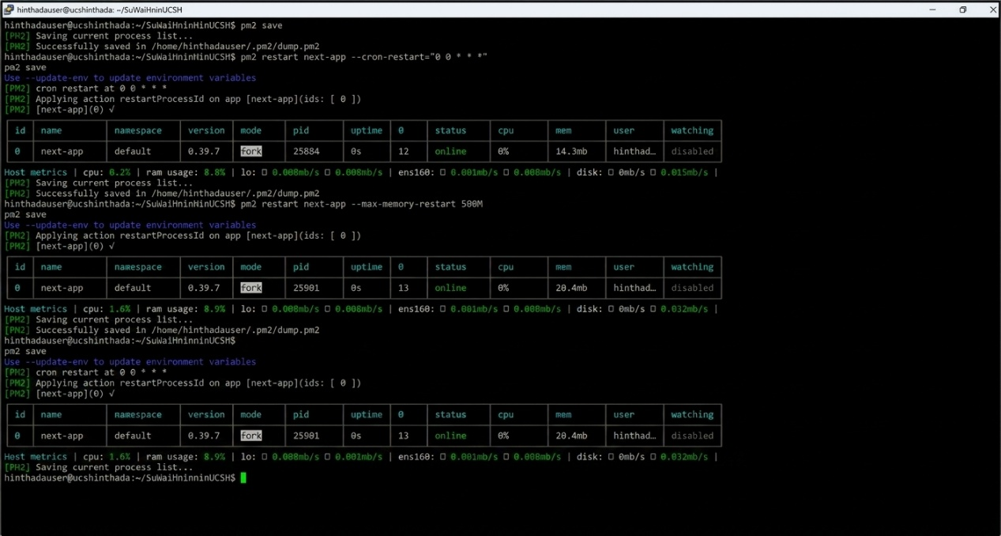
Figure 4. 16 Successful Deployment of the Leave Management System

CHAPTER 5

CONCLUSION
The Leave Management System is developed to improve and simplify the staff leave administration process at the University of Computer Studies, Hinthada (UCSH). The system provides a convenient, paperless, and organized way to submit, review, recommend, approve, and monitor staff leave applications. By replacing the traditional paper-based process with a web-based system, it helps reduce processing time, improve data accuracy, and make leave information easier to access and manage. Furthermore, it establishes a centralized database that supports the university's digital transformation while eliminating manual tracking and ensuring data integrity across departments.
The system is developed using the Laravel Framework, PHP, MySQL, HTML, CSS, Bootstrap, Tailwind CSS and JavaScript. It provides a secure, responsive, and user-friendly interface for System Admin, Administrators, Department Heads, and staff members. Core functionalities include user management, online leave application with substitute staff designation, multi-tier approval workflows, filtered report generation for management, notifications, and dashboard analytics.
The system enhances workflow transparency and administrative efficiency throughout the leave application process. Staff members submit applications online with substitute staff designations, Department Heads review and recommend requests, and Administrators make final approvals. Non-recommended requests are returned directly to applicants with automated notifications, while System Admins oversee system privileges. This process ensures full compliance with institutional administrative procedures.
By digitizing the leave management process, UCSH can reduce paperwork, minimize human errors, improve record accuracy, and efficiently monitor staff leave activities. The centralized database also allows authorized users to retrieve and manage leave information more easily, supporting accurate reporting and informed administrative decision-making.
In conclusion, the Leave Management System provides an efficient, secure, and reliable solution for managing staff leave at UCSH. Its centralized and scalable design demonstrates how web technologies improve higher education administration while providing a solid foundation for future enhancements.

5.1 Advantages of the System
Integrating the Leave Management System into the university's administrative infrastructure provides numerous advantages:
- Accurate & Error-Free Management: Ensures accurate leave records, minimizes processing errors, and improves overall leave management.
- Real-Time Online Submissions: Enables staff members to submit leave applications online and monitor the status of their requests in real time.
- Enhanced Transparency: Improves transparency and accountability by providing a standardized multi-role recommendation and approval workflow for administrators and Department Heads.
- Automated Workflow & Efficiency: Reduces administrative workload by automating leave application routing, recommendation tracking, leave balance calculations, and record management.
- Centralized Data Security: Supports secure and centralized storage of staff and leave information, minimizing the risk of data loss.
- Streamlined Data Access: Makes it easier for administrators to search, update, and manage staff records and leave applications through an organized web-based interface.
- Data-Driven Decision Making: Facilitates better administrative decision-making by providing leave reports, summaries, and dashboard analytics.
- Scalability & Future Integration: Provides a scalable and maintainable platform that can be enhanced with additional features such as email notifications, and advanced leave analytics in the future.

5.2 Limitations and Future Work
Although the current version of the proposed Leave Management System successfully achieves its main objectives, several limitations remain. First, the system is specifically designed according to the administrative procedures and organizational structure of the University of Computer Studies, Hinthada (UCSH). Therefore, modifications to the system's code and workflow would be required to adapt it to other universities or organizations with different administrative structures and leave policies. Second, although the system provides email notifications to inform users about leave recommendation and approval statuses, it does not currently support instant mobile push notifications or SMS alerts. Third, although the system features a multi-tier recommendation and approval workflow, it does not currently support complex multi-tiered approval chains for specialized leave types or temporary delegation of approval authority when a Department Head or Administrator is unavailable. In addition, the system is designed as a web-based application and does not provide a dedicated native mobile application. Finally, the current system provides only basic reporting and analytics features, which limits the ability to perform advanced analysis and decision-making based on leave-related data.
For future work, several enhancements can be considered to improve the functionality, flexibility, and usability of the system. First, real-time SMS alerts and mobile push notifications could be integrated to provide faster status updates to users. In addition, dedicated cross-platform mobile applications for Android and iOS could be developed to offer seamless access on mobile devices. Furthermore, an automated delegation feature could be added to temporarily transfer approval authority when a Department Head or Administrator is unavailable. Lastly, advanced data analytics and predictive visualization tools could be implemented to better support long-term administrative decision-making. These enhancements would make the system more flexible, accessible, and suitable for future expansion and adoption by other organizations.

REFERENCES
- Laravel Documentation. The PHP Framework for Web Artisans. Retrieved from https://laravel.com/docs
- PHP Documentation. PHP Manual. Retrieved from https://www.php.net/docs.php
- MySQL Documentation. MySQL 8.0 Reference Manual. Retrieved from https://dev.mysql.com/doc/
- Mozilla Developer Network (MDN Web Docs). HTML, CSS, and JavaScript Documentation. Retrieved from https://developer.mozilla.org
- Bootstrap Documentation. The World's Most Popular Front-End Toolkit. Retrieved from https://getbootstrap.com/docs/
- XAMPP Documentation. Apache Friends – XAMPP for Windows. Retrieved from https://www.apachefriends.org
- phpMyAdmin Documentation. phpMyAdmin Documentation. Retrieved from https://docs.phpmyadmin.net/
- MySQL Workbench Documentation. MySQL Workbench Manual. Retrieved from https://dev.mysql.com/doc/workbench/en/
- W3Schools. Web Development Tutorials. Retrieved from https://www.w3schools.com
- Ministry of labor- The republic of union of Myanmar, www.mol.gov.mm, May 28, 2010.
- Types of Leave under Myanmar Labor Law - Myanmar Payroll & Outsourcing, Payroll, PEO & HR Services Provider - Myanmar Payroll & Outsourcing (myanmar-payroll-and outsourcing.com.mm), 2024.
- Stauffer, Matt. 2019. Laravel: Up & Running: A Framework for Building Modern PHP Apps. 2nd ed. Sebastopol, CA: O'Reilly Media.
- Turner, Andy. Update PHP Laravel 9.x: Learning Laravel with Easiest Way. Home Learning Center, 2022.
- Joshi, A. (2025). The Laravel 12 blueprint: A comprehensive guide to modern PHP development. 101 Books.
- Phyoe, A Zin, and Win Theingi Htet. "Airline Reservation System (For Burmese-Wings)." University Journal of Student Projects and Research, vol. 1, Nov. 2024, https://ucsh.edu.mm/?page_id=6057.
- Thit, Pwint Yar Su, and Shwe Yamone Aye. "Employee Leave Management System." University Journal of Student Projects and Research, vol. 1, Nov. 2024, https://ucsh.edu.mm/?page_id=6057.
- Aung, Zaw Zaw, Nway Nway Hlaing, and Aye Thandar Kyaw. "IoT Based Reservoir Control System." University Journal of Student Projects and Research, vol. 1, Nov. 2024, https://ucsh.edu.mm/?page_id=6057.
- Aung, Yee Wai, Phyo Htet Wai, and Myat Min Htet. "Remote-Controlled Seed Sowing and Water Spraying Robot." University Journal of Student Projects and Research, vol. 1, Nov. 2024, https://ucsh.edu.mm/?page_id=6057.
- San, May Myat Thu, and Thet Hnin Hsu. "Online Grocery Store System." University Journal of Student Projects and Research, vol. 1, Nov. 2024, https://ucsh.edu.mm/?page_id=6057.
- Htun, Yadanar Nadi. "Online Resume Builder for Job." University Journal of Student Projects and Research, vol. 1, Nov. 2024, https://ucsh.edu.mm/ ?page_id=6057.
- Soe, Myat Thazin. "Paddy Pests Information System." University Journal of Student Projects and Research, vol. 1, Nov. 2024, https://ucsh.edu.mm /?page_id=6057.
- Kyaw, Soe Zay Yar, and Thaw Zin Phyo. "Student Registration & Grading Certificate Creation System." University Journal of Student Projects and Research, vol. 1, Nov. 2024, https://ucsh.edu.mm/?page_id=6057.
- Sin, Kyawt Shwe, Kyaw Kyaw Thu, and Kyaw Thein Win. "IoT Based Monitoring System for Warehouse Security." University Journal of Student Projects and Research, vol. 1, Nov. 2024, https://ucsh.edu.mm/?page_id=6057.
- Khant, Min Kaung. "AI-Powered Diagnosis and Disease Management System." University Journal of Student Projects and Research, vol. 2, Oct. 2025, https://ucsh.edu.mm/?page_id=6914.
- Lwin, Thant Wai. "Internet Banking Transaction System." University Journal of Student Projects and Research, vol. 2, Oct. 2025, https://ucsh.edu.mm/? page_id=6914.
- Kyaw, Nanda, and Saw Hla Nandar. "SmartGrade: Grading Certificate Information System (Client-Server)." University Journal of Student Projects and Research, vol. 2, Oct. 2025, https://ucsh.edu.mm/?page_id=6914.

